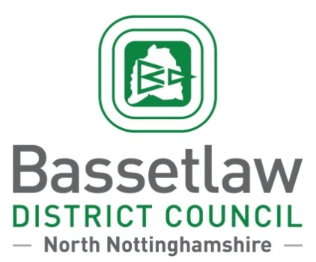

**PRESS RELEASE**

Queen’s Buildings, Potter Street, Worksop, Nottinghamshire, S80 2AH

**Contact:**  Tina Masters **Date:** 04/07/2025

Media Officer

**Tel:**  01909 533 533 **Ref:** PR 3055

**From Worksop to New England: History is being brought to life in Bassetlaw**

Bassetlaw’s connections to New England in America are being brought to life at The Bridge Skills Hub in Worksop.

Dr Charlotte Carrington-Farmer, a professor of history at Roger Williams University in the U.S., will give a presentation next month on the 17th century life of Mary Williams called ‘Mary Williams: From Worksop to New England’.

The talk will explore Mary’s early life in Worksop, where her father, Richard Bernard, was the vicar at the Priory, while telling her story represents a pivotal step in the larger movement to reveal the voices of women whose participation have gone unacknowledged in the historical record.

It’s taking place on Tuesday 5th August at 5:30pm and has been organised in partnership with Bassetlaw District Council and the Worksop Priory and Gatehouse Community Trust.

Fran Walker, Chair of the Community Trust said: “This is a unique opportunity in the history of the Gatehouse to celebrate the importance of those who occupied the area in the 17th Century, and to encourage pride in our rich heritage throughout the world”

The talk draws on Dr. Carrington-Farmer’s recent work, including her article “More than Roger’s Wife, Mary Williams and the Founding of Providence,” *New England Quarterly* (2024) and her new book, [*Roger Williams and His World*](https://url.uk.m.mimecastprotect.com/s/84WkCW79XS6rwmrF6fqioszyp?domain=broadviewpress.com)*: A History in Documents* (Broadview Press, 2025.)

Cllr Steve Scotthorne, Cabinet Member for Identity and Place said: “It is great to be able to welcome Dr Charlotte Carrington-Farmer to Bassetlaw, where Mary Williams spent the early years of her life.”

“The district is very proud of its heritage, and this event is a good way to find out more about those who left Worksop behind and set up home in New England.”

To book visit: www.eventbrite.co.uk/e/mary-williams-from-worksop-to-new-england-tickets-1460504230469