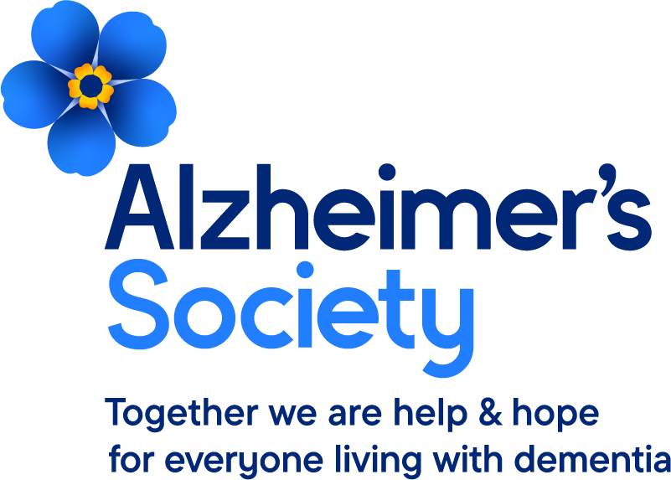

How to make a professional referral – Nottingham and county.
- Please ensure you have consent then go to our website www.alzheimers.org.uk

- Press the professional referral button on the top right of the home page.

- Enter the required details. Please indicate how urgent the referral is and what you feel is needed eg. Home visit, urgent call. The more information you can give us the easier it will be to triage and get help at the appropriate time.

- You will be sent a referral code which you can use on future referrals to avoid having to input your details again. This can be shared with everyone in your organization.

- Your referral as a professional will immediately be sent through to our Nottinghamshire triage desk bypassing the National Support Line which will speed up the process.

- Please be aware though that there is usually a waiting list of several weeks but referrals marked urgent will take priority. We send out a letter to anyone waiting acknowledging the referral and informing them of the wait time.

- Bassetlaw only: Any referees living in Bassetlaw are also immediately sent an invitation to our Dementia Peer Support Hubs there where they can turn up without booking and receive immediate support from a Dementia Adviser, benefits team, social services and carers federations amongst others.

Self referral can be made by anyone needing support eg. Family member of person with dementia, partner or person living with dementia.
- Anyone can self refer to us using the National Support Line number of 0333 150 3456.

- The National Support Line number operates 7 days a week and in the evenings on some days. It is staffed by telephone Dementia Advisers throughout the country. If the Support Line is not open, a message can be left and we will get back to the person.

- Calls will either be dealt with by the telephone Dementia Adviser if simple such as requesting publications or dementia advice but where local support is needed, the situation is more complex or a home visit is required, then the referral will be sent to the local Services Manager to be allocated to a local Dementia Adviser who will make contact with the referee as soon as they can and dependent on the urgency of the situation.

Anonymous referrals and personal referrals.
- Anyone can make a referral about someone they are concerned about even where consent has not been gained. This might be where someone is concerned about a neighbour or friend who has dementia or is caring for someone with dementia. If you come across someone who is concerned you could also encourage them to let Social Services know of their concern which again, can be anonymous.

- Follow the instructions above for the self referral and if applicable let the Adviser know that you do not wish to leave your details so it can be logged as anonymous.

