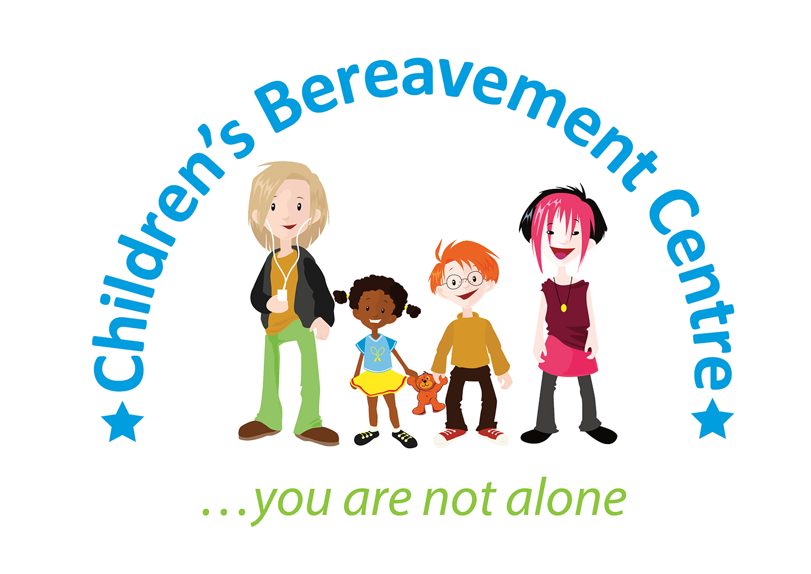

**Trustee/Treasurer**

The Children’s Bereavement Centre is a highly respected Nottinghamshire-based charity who has been providing specialist support to children, young people and their families since 2003.

We are seeking a trustee/treasurer to take over from our long-standing treasurer to help us continue to build on our success and improve the lives of bereaved children and their families. The successful candidate will have a finance and/or accounting background and will work with the Board of Trustees to ensure the charity’s financial viability.

Key responsibilities will include

* attending quarterly board meetings and presenting financial reports
* overseeing the charity’s financial management and legal/regulatory compliance
* ensuring robust processes and controls are in post
* advising on financial strategy, risk management and financial policies and procedures
* Ensuring the annual accounts are prepared in accordance with charity regulations

We are keen to recruit a Treasurer committed to our vision and values who has:

* Financial qualifications and experience
* Some knowledge of charity finance, fundraising and pension schemes
* Strong analytical skills and the ability to present financial information clearly.
* Experience in governance, leadership, or financial oversight.

To find out more please contact our Chief Executive, Kate Baxter on 07703 566170 or email [kate@childrensbereavementcentre.co.uk](mailto:kate@childrensbereavementcentre.co.uk). Applicants will be required to complete an application form. Closing date: Monday 30 June 2025.

*Appointments are subject to receiving an enhanced disclosure from the Disclosure and Barring Service which we consider acceptable and two satisfactory references. We actively encourage applicants from diverse backgrounds.*