Promotional Launch Pack
Public Awareness
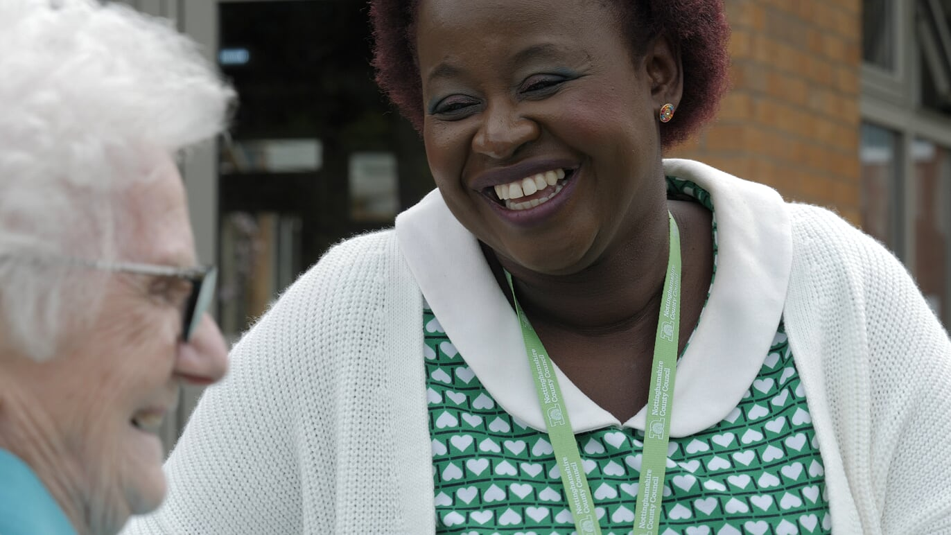

About the End of Life Care Toolkit
Approximately 1% of the UK’s population die each year, and within that population the majority of deaths can be predicted. Evidence has found that early identification of patients who are likely to die within the next 12 months often enables well coordinated, pro-active quality care, and allows healthcare professionals to focus on better meeting patients’ needs. It has been developed in partnership with Marie Curie and the Clinical Innovation and Research Centre.
The Nottingham and Nottinghamshire End of Life Care Toolkit provides a collection of tools, knowledge, and current guidance for healthcare professionals to support patients nearing the end of life to live well until they die.
The resources are for healthcare professionals, informal carers, patients and those who support them.
Every year, people around the UK use Dying Matters Awareness Week as a time to encourage all communities and families to get talking in whatever way, shape or form works for them. We have decided to combine this week by promoting both Dying Matters which will take place between 5th and 11th May, and the Nottingham and Nottinghamshire End of Life Care Toolkit.
Resources with weblinks include:
- Patient case studies
- Social media content
- Useful resources
- Podcasts
- Dying Matters Awareness Week resources
- Events

Patient case studies
David’s Story | David's dad died in a care home at the age of 90. To all intents and purposes it was a 'good death'. But David wished that he knew what was going to happen, before it happened. Why are we so reluctant to talk about death? And if we can't think about it, then how can we plan for it?  There is no right or wrong place to die; it will be different for everyone. But it is important for families to think about it, to talk about it and to plan for it.  This Dying Matters Awareness Week, we need you to help us understand more about people's experiences at the end of life, and for those close to them. Join the movement today.  Discover more at dyingmatters.org  Video length: 1 minute 30 seconds
Ike’s Story | "She did everything she needed to do for me and my children."  When Ike's wife Mimi was diagnosed with terminal cancer aged just 37, Ike didn't want to hear about the plans that she was putting in place to make sure Ike and their two children were able to cope after she had gone. But he soon discovered that the preparations she made were a huge help to the family.  Many of us, like Mimi, have thought about where we would like to die, and how to organise our affairs, but have we told our loved ones?  This Dying Matters Awareness Week, we need you to help us understand more about people's experiences at the end of life, and for those close to them. Join the movement today.  Discover more at dyingmatters.org  Video length: 3 minutes 7 seconds
ACP Day Stories - website  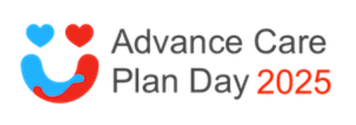 | Several stories that highlight the benefits of planning ahead and having honest conversations.
Dying is not as bad as you think. BBC Ideas | Dr Kathryn Mannix. Palliative Care Consultant, author and speaker.  Video length: 4 minutes

Share our social media posts and graphics
#TheCultureOfDyingMatters #ACPDay2025 #Notts_TLC
#endoflifecare #hospice #palliative #eol

 |  | 

Image | Text
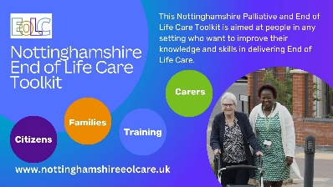 | The Nottinghamshire End of Life Care Toolkit supports individuals in the period leading up to their death, encompassing support for physical, emotional, spiritual, and practical needs. It aims to help individuals live as well as possible and to die with dignity, often including palliative care, hospice care, and supportive care.  Nottinghamshire End of Life Care Toolkit | Home
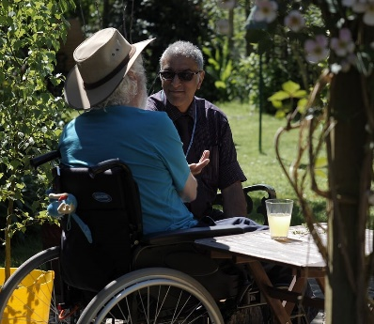 | Support for carers  If you're looking after someone with a life-limiting condition, here are resources that can help you.  Support for carers | Hospice UK
The Nottinghamshire Palliative and End of Life Care Toolkit is aimed at staff in any setting who want to improve their knowledge and skills in delivering End of Life Care. It has been created by End of Life Care professionals from Nottinghamshire, who are dedicated to sharing the most current and relevant information with clinical teams and the public.

Nottinghamshire End of Life Care Toolkit | Home
 | This Dying Matters Awareness Week, we need you to help us understand more about people's experiences at the end of life, and for those close to them.  When Ike's wife Mimi was diagnosed with terminal cancer aged just 37, Ike didn't want to hear about the plans that she was putting in place to make sure Ike and their two children - Ike Jnr and Chimamanda - were able to cope after she had gone.  Your stories - Ike and Mimi | Hospice UK
 | #DyingMattersWeek  What should I say? It can be very difficult to know what to say or do when someone you know has lost someone close. We often want to offer support.  Many people rely on friends and relatives to support them through a bereavement, but there are different types of services and information available that can also help if you need them.  I need support with a bereavement | Hospice UK

Useful resources
Nottingham and Nottinghamshire EOL Care Toolkit | Local information to inform and help you about support when approaching the last years of life.
‘What is Advance Care Planning’ MP4 on Vimeo | Supporting you to make plans for the future
Dying Matters Website | Hospice UK’s Dying Matters campaign is working with you to create an open culture in which we’re comfortable talking about death, dying and grief.
Advance Care Plan Day | Practical things you can do to raise awareness including social media resources.
Carers Federation Hub Support | Lots of useful information for informal carers.
Talking Points Conversation Cards | Downloadable cards you can use with friends, family & groups.
Hope For the best, Plan for the rest | Book to help people navigate a life changing diagnosis.
MyWishes | MyWishes is a free to use, 'tech for good' platform. Supporting you to make plans for your future self and the people who are important to you.

Printable posters
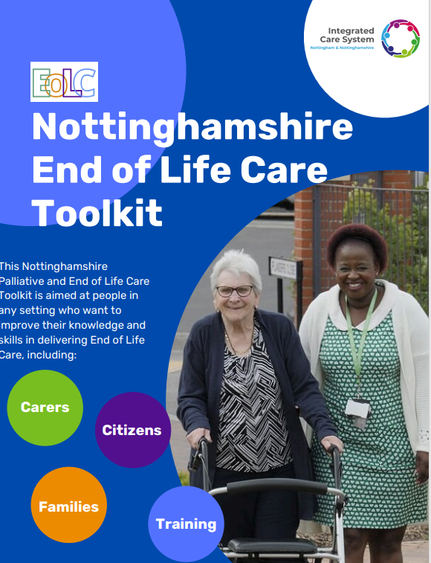 | Download the low resolution poster for digital use.

Recommended Podcasts
On the Marie Curie Couch  Stories & experiences  Dying Matters Podcast  Having better conversations  The Waiting Room Revolution  How to have a better conversation.  Speak For Me  Clare Fuller on ACP | 

Dying matters awareness week resources

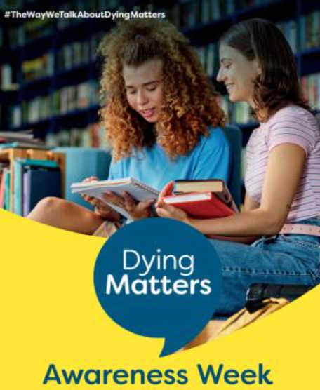 | 5th – 11th May 2025  Dying Matters Awareness Week resources, including supporter and library packs, posters, reading lists, social media graphics, bunting, animated film, and more!  Click here:  Dying Matters Awareness Week Resources | Hospice UK

Events
Dying Matters awareness raising event – 6th May | Where: Macmillan Information and Support Centre in the YMCA Activity and Community Village (Lord Hawke Way, Newark)  Time: 11.30am until 4.00pm.  The event will enable us to share resources, talk about the services provided locally and to share conversations with anyone who joins us. This will also be a fabulous opportunity to visit the new Centre and see the resources and support that will be available locally for patients with a cancer diagnosis, and for those important to them too.
Advance Care Plan Day – 7th May | https://advancecareplanday.org/

