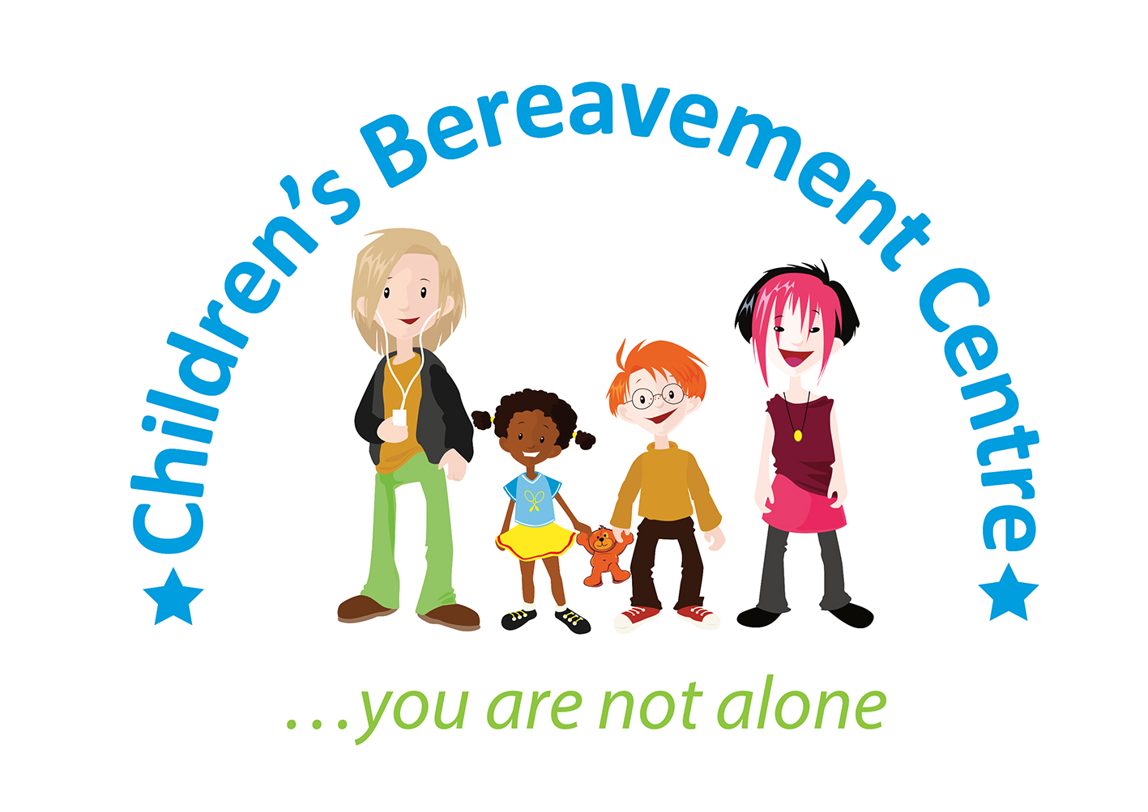

**Chair of Trustees**

The Children’s Bereavement Centre is a highly respected Nottinghamshire-based charity who has been providing specialist support to children, young people and their families since 2003.

We are seeking a new Chair to lead our Board to replace our long-standing Chair. The role will involve helping us to build on our success and ensure that we continue to improve the lives of bereaved children and their families.

Key responsibilities will include chairing quarterly board meetings, ensuring robust governance practices and acting as the main liaison with the Chief Executive.

We are keen to recruit a Chair committed to our vision and values who has:

* Significant leadership experience, ideally within a public or charitable sector setting
* Understanding of charity governance, finance and strategic planning
* Strong financial and risk management acumen
* Excellent communication skills

To find out more please contact our Chief Executive, Kate Baxter on 07703 566170 or email [kate@childrensbereavementcentre.co.uk](mailto:kate@childrensbereavementcentre.co.uk). Applicants will be required to complete an application form. Closing date: Monday 30 June 2025.

***Appointments are subject to receiving an enhanced disclosure from the Disclosure and Barring Service which we consider acceptable and two satisfactory references. We actively encourage applicants from diverse backgrounds.***