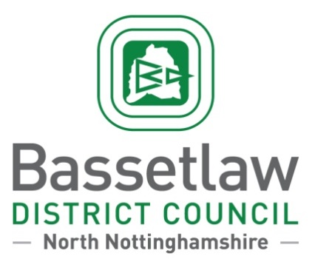

PRESS RELEASE

Queen’s Buildings, Potter Street, Worksop, Nottinghamshire, S80 2AH

**Contact:** Tina Masters **Date:** 30/10/2024

Media Officer

**Tel:** 01909 533 533 **Ref:** PR 2922

**Have your say on how Bassetlaw District Council’s budget is spent**

Bassetlaw District Council is inviting residents, businesses, and stakeholders to help shape future services and balance the books.

The council is launching the Budget Conversation, a survey to find out which services people use the most and capture any ideas on ways to make potential savings.

Each year, the council has funds of around £20.9m to provide essential services, pay for important local projects and fund vital community-based initiatives among other things.

Despite a prudent approach and robust forward planning, Bassetlaw District Council’s Medium Term Financial Plan is projecting a budget shortfall of £3.8 million over the next five years.

Cllr Alan Rhodes, Cabinet Member for Corporate and Financial Services said:

“Costs have risen due to inflation, increases in energy, fuel, and the cost of materials, this comes alongside a significant reduction in funding.

“We hope people take the time to tell us their views, their responses will be highly valued, and it will be crucial in helping inform the decisions we make and support us to shape our future services.”

The Budget Conversation launches on 1st November and runs until 12th December 2024, with the council inviting as many people as possible to share their feedback.

The results of the survey will be used as part of the budget setting process, culminating in the annual budget meeting on 27th February 2025, where Bassetlaw District Council will set spending for the next fiscal year and agree yearly savings targets for the next five years until 2030.

Those who complete the survey also have the chance to win one of six £25 Love2Shop vouchers.

To take part in the five-minute survey visit [www.bassetlaw.gov.uk/budget-2024](https://www.bassetlaw.gov.uk/budget-2024) or pick up a hard copy from one of the following locations:

Carlton Civic Centre, Langold Village Hall, The Misterton Centre, Mattersey Community House, Retford Shopmobility, Worksop Shopmobility, Council Offices - Retford, Chancery Lane, Council Offices – Worksop, Queens Buildings, Harworth Town Hall, Tuxford Walks of Life Museum, Sally Mitchell Fine Arts, Newcastle Arms, Tuxford