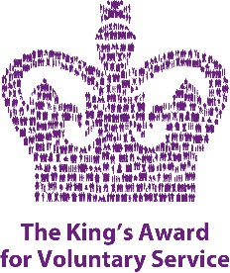

**KAVS**

**Introduction**

Previously the QAVS the award began life in 2002 as part of the Queen’s Golden Jubilee to recognise and honour the countless volunteers in this country who make up the backbone of so much of community life. It is the equivalent of an MBE. The first awards were made in 2003. The current national Chair is Sir Martyn Lewis. It is managed by Department for Digital, Culture, Media and Sports (DCMS)

Volunteer-led work will cover a wide range of fields including, mental health, youth, community, arts and heritage.

The criteria set out for the award include:

* The group must be volunteer led.
* There must be two or more people in the group
* Half the group must have rights to live in the UK
* Their work must be recognised and respected for and by the local community
* They must have been running the service for three years or more.
* They may be part of a larger national organisation but there would need to be something unique about the group in Nottinghamshire.

Their work may include international service but the majority of their work needs to be in this country.

**New KAVS Timeline from 2024**

Nomination window 1st September to 1st December 2024

Local Assessment 1st January to 12th April 2025

National Assessment ends 21st June 2025

Awardees and LLs notified in confidence early October 2025

Awardees announced 14th November 2025

There is an on-line nomination form. The nominator cannot be a member of the group but someone who knows the group well. There needs to be two letters of support. These need to highlight not only the work of the volunteers but the impact of what they do. One could be from someone who has directly benefited from the work of the volunteers. When local assessors come to write their report they will be looking at many aspects of the group, including financial probity and safeguarding.

Sometimes people think this award is only for charities, but it is for all groups of volunteers who meet the criteria of the award.

More information can be found at <https://kavs.dcms.gov.uk>

More advice can be obtained from the Notts Lieutenancy – [lieutenancy@nottscc.go.uk](mailto:lieutenancy@nottscc.go.uk)