Press Release: Celebrate Diversity at the Bassetlaw Multicultural Festival 2024
For Immediate Release
Bassetlaw Multicultural Festival returns to Worksop on 14th September 2024
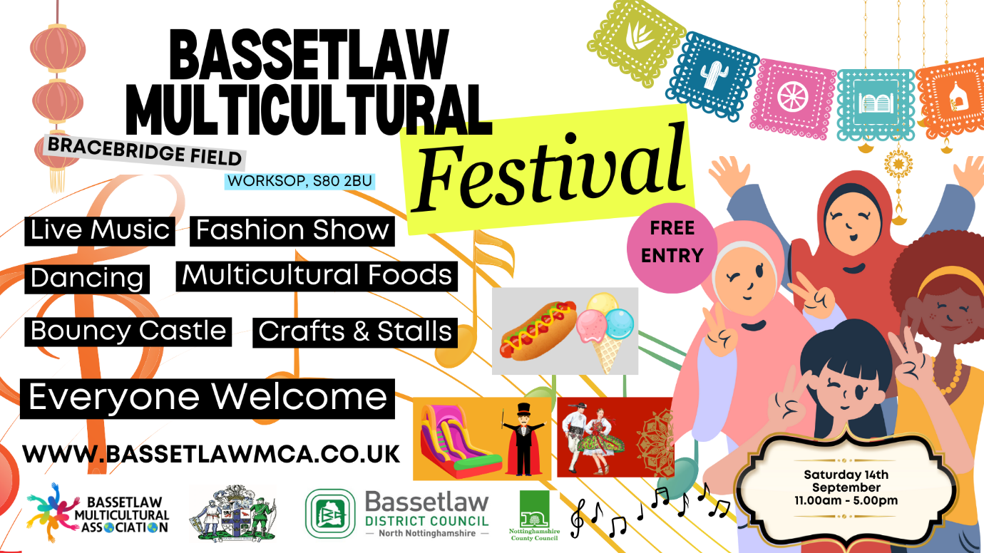

The vibrant and diverse community of Bassetlaw is coming together for a day of celebration at the Bassetlaw Multicultural Festival, taking place on Saturday, 14th September 2024, from 11:00 AM to 5:00 PM at Bracebridge Field, Worksop. Entry to the festival is FREE OF CHARGE.
This much-anticipated event promises to be a joyful celebration of the rich tapestry of cultures that make up our local community, and everyone is invited to join in the fun.
The Bassetlaw Multicultural Festival is more than just an event—it's a day dedicated to embracing diversity, promoting inclusivity, and celebrating the unique cultural heritage that each member of our community brings. From live music performances that will get you dancing to the beat of different cultures, to a diverse selection of world foods that will take your taste buds on a global journey, there is something for everyone to enjoy.
Families can look forward to a wide range of activities and games designed to entertain all ages. There will be community stalls where you can learn more about local organisations and initiatives, as well as craft and product stalls offering unique items. Whether you're looking to try something new, support local organisations, or simply enjoy a fun day out with the family, the Bassetlaw Multicultural Festival has it all.
The Bassetlaw Multicultural Festival is a shining example of these principles in action. It provides an opportunity for people from all walks of life to come together, learn about different cultures, and celebrate what makes each of us unique.
The safety of all attendees is a top priority. The festival committee have implemented a comprehensive security plan in partnership with Nottinghamshire Police to ensure that everyone can enjoy the festival in a safe and welcoming environment.
Whether you're a long-time resident or new to the area, the Bassetlaw Multicultural Festival is open to everyone. It's a chance to come together as a community, celebrate our shared values, and enjoy a day of entertainment, culture, and fun.
Mark your calendars for Saturday, 14th September 2024, and join us at Bracebridge Field, Worksop, for a day you won't forget.
For more information about the festival, please contact info@bassetlawmca.co.uk or visit www.bassetlawmca.co.uk , which can be translated into multiple languages.

