Welcome to **‘A Little TLC’** … **Tackling Loneliness Collaborative’s** ‘useful community information!’ – **9th August 2024.**

Please feel free to have a glance through the headlines or see further details further down..…

**Just to mention in light of recent events:**

*The Tackling Loneliness Collaborative (TLC) Nottingham & Nottinghamshire is an inclusive and supportive space. Our aim is to work together with a focus on loneliness.*

*The MP Jo Cox is famous for saying ‘We have more in common than that which divides us’.* [*https://www.jocoxfoundation.org/*](https://www.jocoxfoundation.org/) *Loneliness can affect anyone.*

The focus this time is: **‘Community!’**

**Headlines:**

1. Neighbourhood Get-Together! Broxtowe – 2 Friday evenings a month starting 9th August – see details below – click to book: [https://forms.gle/mqg3EryYeyE8Eavx6](https://forms.gle/mqg3EryYeyE8Eavx6?fbclid=IwZXh0bgNhZW0CMTAAAR1x0NvEm9xV8gzRRLrMDfOA08NI38MFgLHzNozj8MdVAUjTO1AW2uIatXc_aem_CLcuhYXlj5gRalfooIh4xA)
2. South Normanton Bottled Up Blokes (BUB) Hub. Meets every Thursday at 7pm. [**www.bottledupblokes.com**](http://www.bottledupblokes.com)
3. Age UK – Best Foot Forward Walk – Carlton Hill - [https://www.ageuk.org.uk/.../best-foot-forward-timetable...](https://www.ageuk.org.uk/bp-assets/globalassets/nottingham--nottinghamshire/downloads/best-foot-forward-timetable-of-walks-part-1-v1.2.pdf?fbclid=IwZXh0bgNhZW0CMTAAAR3yYLM1UT3c_HROfEyAtwNY3ddm07oZE8sAYhC3UiO1shyHIFqG0o9VKpU_aem_ne5MPavpkdrZJGDrfqb8dw)
4. Community Re-paint – make an appointment to pick up part used paint from 4 Recycling Centres - [Community RePaint | Veolia Nottinghamshire](https://www.nottinghamshire.veolia.co.uk/Paint)
5. [Finding and engaging harder to reach older people in housing settings Tickets, Thu, Aug 29, 2024 at 3:30 PM | Eventbrite](https://www.eventbrite.co.uk/e/finding-and-engaging-harder-to-reach-older-people-in-housing-settings-tickets-951379761477?aff=ebemoffollowpublishemail&ref=eemail&utm_campaign=following_published_event&utm_content=follow_notification&utm_medium=email&utm_source=eventbrite)
6. [Self Harm Awareness training (Nottingham and Nottinghamshire) Tickets, Wed 21 Aug 2024 at 09:30 | Eventbrite](https://www.eventbrite.co.uk/e/self-harm-awareness-training-nottingham-and-nottinghamshire-tickets-957034334457?aff=ebemoffollowpublishemail&ref=eemail&utm_campaign=following_published_event&utm_content=follow_notification&utm_medium=email&utm_source=eventbrite)
7. Funding available for West Bridgford community groups to support their growth - [West Bridgford Expressions of Interest - Rushcliffe Borough Council](https://www.rushcliffe.gov.uk/planning-growth/cil/west-bridgford-expressions-of-interest/)
8. Talk Club – Mental Fitness Community for Men – See poster below - [www.talkclub.org](http://www.talkclub.org)
9. [Increasing Diversity of Inclusion within Co-production Tickets, Wed, Sep 4, 2024 at 2:00 PM | Eventbrite](https://www.eventbrite.co.uk/e/increasing-diversity-of-inclusion-within-co-production-tickets-979980828037?aff=ebemoffollowpublishemail&ref=eemail&utm_campaign=following_published_event&utm_content=follow_notification&utm_medium=email&utm_source=eventbrite)
10. [Places Of Welcome - CUF](https://cuf.org.uk/places-of-welcome?fbclid=IwY2xjawEi03VleHRuA2FlbQIxMAABHSUM7FaPj3JRJ8H0HszW12Ry-35SzR4OgZT0vQVBcYtEWoW4qonMgwLSWA_aem_TkdTa9RvQGUnUnHOzD05uA)  Various venues mapped on the Church Urban Fund Website [The Map - CUF](https://cuf.org.uk/places-of-welcome-map)

***TLC dates for your diary:***

* Our next wider **Tackling Loneliness Collaborative (TLC) meeting** takes place on **Tuesday 10th September 2024 9:30am-11:00am** on MS Teams.

[**Click here to join the wider TLC meeting**](https://teams.microsoft.com/l/meetup-join/19%3a058d99892c25477ba09b0e7d1fbc2d11%40thread.tacv2/1709836741123?context=%7b%22Tid%22%3a%223a4e48d5-2a9d-45aa-8001-70f6a8186d0e%22%2c%22Oid%22%3a%22c4fdd0c2-c73b-4913-b114-429273bf0be4%22%7d)If you have anything you want to share in this meeting please feel free to!



* **The Little TLC Catch Up!** – **Tuesday 3rd September** **– 12pm-12:30pm on MS Teams.**It’sour informal peer networking lunch gathering.

[**Join the Little TLC Catch Up! Meeting**](https://teams.microsoft.com/l/meetup-join/19%3ameeting_NmMxYmViMWMtYzc4MC00MGEzLTgyM2UtMmQyMGYxNDk1MDA0%40thread.v2/0?context=%7b%22Tid%22%3a%224df4435f-8800-4e1e-a615-b287fcaa7120%22%2c%22Oid%22%3a%220325b866-b80d-4b91-9992-7e06eb2c7739%22%7d)   Meeting ID: 398 636 962 177   Passcode: FrXVGs

 All welcome; it’s great to meet a little more informally and share tips or what we are up to in a gentle drop-in space whilst nibbling lunch!

**Updates:**

**Website:** We have appointed a Web design company who have started to build and design the TLC Website – now is the time to let us know what you think should or shouldn’t be included on there!

**Friendly Connector:** We are in the process of really thinking about the design and actual information to go on the single point information card following on from 2 workshops we’ve held and comments you’ve shared. I’ve been out to present this model to some of the management at East Midlands Ambulance Service – which was warmly received and also I’ve spoken with some interesting and friendly people at Kirkby in Ashfield Library Place of Welcome group to talk about this and the TLC.

**TLC Conference:** Will take place on the **12th of November at the ICCA** <https://www.theicca.co.uk/> - a lovely, flexible venue from **9:30am – 4pm.** It promises to be a really interesting and interactive day. Click here to email to book if you’ve haven’t already and would like to: [**TLC Conference Booking**](mailto:kirsty.veitch-sorsby@bcvs.org.uk)  More details will follow.

Many thanks, Kirsty

Tackling Loneliness Collaborative Lead

Find us on [Facebook](https://www.facebook.com/tacklinglonelinesscollaborative)  and ‘X’ ([Twitter](https://twitter.com/TLCNotts))

Loneliness Page – [Tackling Loneliness Collaborative Nottingham and Nottinghamshire | Bassetlaw CVS (bcvs.org.uk)](https://www.bcvs.org.uk/tlcnn)

Research and Service Database -  [www.tlin.co.uk](http://www.tlin.co.uk/)

           …………………………………………………………………………………………………………………………………………………………………………………………………………………………………………………………………………….…….

***Items to follow:***

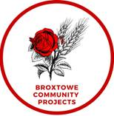🌟Neighbourhood Get-Together! 🌟

Join us every two Fridays for some fun and community spirit! This week, we're crafting 🎨polymer clay magnets and enjoying a lovely 🧺picnic afterwards. Everyone's welcome, so come meet your neighbours! We celebrate and support everyone, including our 🏳️‍🌈LGBTQIA+ friends and those who are neurodiverse or have learning differences.

💖Donation: £2 per adult or £1 per child (maximum of £5 per family) to support our small charity.

🕔Time: 5:15 PM on 09.08.2024

📍Location: 1st Stapleford & Trowell Scout Group

behind the fire station, Pinfold Ln, Stapleford, Nottingham NG9 8DL

We can't wait to see you there! ✨Reserve your spot by clicking the link below:

[https://forms.gle/mqg3EryYeyE8Eavx6](https://forms.gle/mqg3EryYeyE8Eavx6?fbclid=IwZXh0bgNhZW0CMTAAAR1x0NvEm9xV8gzRRLrMDfOA08NI38MFgLHzNozj8MdVAUjTO1AW2uIatXc_aem_CLcuhYXlj5gRalfooIh4xA)

[](http://www.bottledupblokes.com/)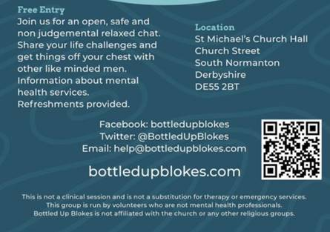

[**www.bottledupblokes.com**](http://www.bottledupblokes.com)

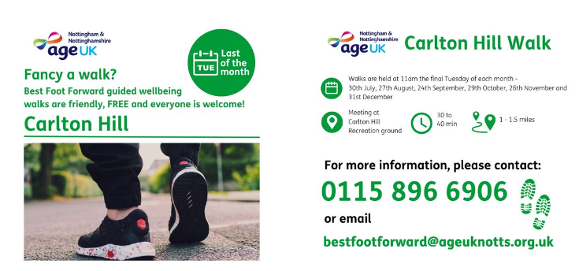

Did you know we offer a new walk on Carlton Hill?

Meeting at Carlton Hill Recreation ground this walk will consist of a short walk around the recreation ground and then down to The Hope Community Hub for refreshments it will take 30 to 40 minutes depending on the mobility of the walkers. There is a local bus that returns to the car park if you don’t want to walk up the hill. It’s a varied walk mostly on pavements and paths and may include grassed areas.

Walks are held at 11am the final Tuesday of each month:

The next weeks are: 27th August, 24th September, 29th October and 26th November.

Walking is such a wonderful way of improving overall fitness, topping up your vitamin D levels (so important for bone health) in the sunshine and creating opportunities to make new friends and socialise.

Why not share details of the Carlton Hill and other walks with your family, friends and the people who use our services and help them to enjoy better health?

For more information about this service:

t 0115 896 6906

[bestfootforward@ageuknotts.org.uk](mailto:bestfootforward@ageuknotts.org.uk)

[www.ageuknotts.org.uk](https://l.facebook.com/l.php?u=http%3A%2F%2Fwww.ageuknotts.org.uk%2F%3Ffbclid%3DIwZXh0bgNhZW0CMTAAAR3SMhjMfhlNQz1EYorUol8szF2RTVr5XUPJ0CKab7Bn9cyfYRpEqVd7YcE_aem_pe7XAUhgljHQfvxtIpdVLQ&h=AT0B2vCpRTFSSaXFLjhg5EviKwL6qD964U8mFAAzJbnIGix7DLGxiX412FKjdo0snB-gKWT8qd3_Vi3EfsUs4s0zOQGxRdrvYBWQiOuFCwFMwx0xc4CHXuD8UkHYnruVhaj1&__tn__=-UK-R&c%5b0%5d=AT3gPxHCJqYAy1tm_fKWJWHK-0aIU36BHamtXOHwBelDkLMzB51yvuHHphFJAg_YgIufZUltpP1yHWuatJ_ozqXWHJoy0MSCnVW5OPCF9hjwQeSVjItlE8CYmnFDqoEVxMDnJXidC7gHZAPUzzZbW2mjP6NoCPISvwV0mNwqRNAXGMBVKTTBhRKI6omF_3SDZijp2wP8Hl-yc0mcgLA0laQ7XDnFnD6j3f6h)

Download our walk timetables here:

[https://www.ageuk.org.uk/.../best-foot-forward-timetable...](https://www.ageuk.org.uk/bp-assets/globalassets/nottingham--nottinghamshire/downloads/best-foot-forward-timetable-of-walks-part-1-v1.2.pdf?fbclid=IwZXh0bgNhZW0CMTAAAR3yYLM1UT3c_HROfEyAtwNY3ddm07oZE8sAYhC3UiO1shyHIFqG0o9VKpU_aem_ne5MPavpkdrZJGDrfqb8dw)

[](https://www.nottinghamshire.veolia.co.uk/Paint)

[Community RePaint | Veolia Nottinghamshire](https://www.nottinghamshire.veolia.co.uk/Paint)

Tins of liquid paint should never be put in your bin at home, unless they are empty or contain only solid dried-up paint residue. When tins of paint from a wheelie bin are emptied into and crushed in the back of a rubbish truck, the paint can spill onto the street and cause problems. Never pour paint down your sinks and drains as it may pollute our water courses.

A much better idea is to donate unwanted paint to our Community Repaint Nottinghamshire scheme located at 4 of the county’s Recycling Centres. The scheme collects reusable, leftover paint and gives it for free to individuals, community groups, charities and schools.  Community groups may use the paint to refurbish rooms or buildings used by their members. Housing associations may redistribute the paint to their tenants. It may be used by other groups for craft activities, for training or may even be used for stage sets by community theatre groups.

### Which Recycling Centres accept tins containing liquid paint?

* [**Beeston Recycling Centre**](https://www.nottinghamshire.gov.uk/waste-and-recycling/recycling-centres/details/beeston)
* [**Calverton Recycling Centre**](https://www.nottinghamshire.gov.uk/waste-and-recycling/recycling-centres/details/calverton)
* [**Newark Recycling Centre**](https://www.nottinghamshire.gov.uk/waste-and-recycling/recycling-centres/details/newark)
* [**Warsop Recycling Centre**](https://www.nottinghamshire.gov.uk/waste-and-recycling/recycling-centres/details/warsop)

[](https://www.eventbrite.co.uk/e/finding-and-engaging-harder-to-reach-older-people-in-housing-settings-tickets-951379761477?aff=ebemoffollowpublishemail&ref=eemail&utm_campaign=following_published_event&utm_content=follow_notification&utm_medium=email&utm_source=eventbrite)[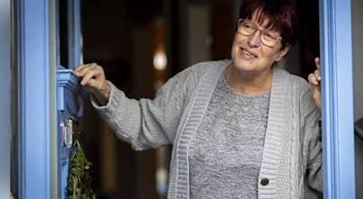](https://www.eventbrite.co.uk/e/finding-and-engaging-harder-to-reach-older-people-in-housing-settings-tickets-951379761477?aff=ebemoffollowpublishemail&ref=eemail&utm_campaign=following_published_event&utm_content=follow_notification&utm_medium=email&utm_source=eventbrite)

**Thursday, August 29 · 3:30 - 4:45pm**

[Finding and engaging harder to reach older people in housing settings Tickets, Thu, Aug 29, 2024 at 3:30 PM | Eventbrite](https://www.eventbrite.co.uk/e/finding-and-engaging-harder-to-reach-older-people-in-housing-settings-tickets-951379761477?aff=ebemoffollowpublishemail&ref=eemail&utm_campaign=following_published_event&utm_content=follow_notification&utm_medium=email&utm_source=eventbrite)

The Good Practice Mentor team invite you to join them for a practical workshop session, exploring practical outreach strategies to support you to find and engage harder to reach older people in housing settings.

If you are a housing provider or engagement team, a member of a Tenants Residents Association (TRA), a community group or organisation keen to engage with harder to reach local people, door knocking can help you to find and successfully engage with residents less likely to attend formal groups and activities.

We’ll discuss the practicalities of door knocking practice, including arranging access and modelling safe behaviour. We’ll also share practical tips and best practice to ensure a positive doorstep conversation. How to informally capture insight from residents, create informal steppingstone opportunities to bring residents together and promote community connection.

[](https://www.eventbrite.co.uk/e/self-harm-awareness-training-nottingham-and-nottinghamshire-tickets-957034334457?aff=ebemoffollowpublishemail&ref=eemail&utm_campaign=following_published_event&utm_content=follow_notification&utm_medium=email&utm_source=eventbrite)

**Harmless has been commissioned to deliver a range of mental health, suicide prevention, self harm and suicide bereavement courses.**

**Wed, 21 Aug 2024 09:30 - 13:30**

[Self Harm Awareness training (Nottingham and Nottinghamshire) Tickets, Wed 21 Aug 2024 at 09:30 | Eventbrite](https://www.eventbrite.co.uk/e/self-harm-awareness-training-nottingham-and-nottinghamshire-tickets-957034334457?aff=ebemoffollowpublishemail&ref=eemail&utm_campaign=following_published_event&utm_content=follow_notification&utm_medium=email&utm_source=eventbrite)

## Funding available for West Bridgford community groups to support their growth

[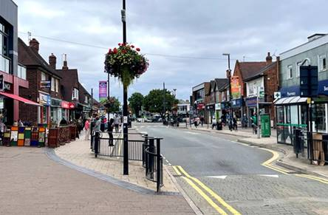](https://www.rushcliffe.gov.uk/planning-growth/cil/west-bridgford-expressions-of-interest/)

Community groups in West Bridgford are invited to apply for funding that will help to grow their club or organisation, to support the development in the town.

We have up to £75,000 of West Bridgford Neighbourhood Community Infrastructure Levy funding available and are looking to support projects with funding contributions up to £25,000 each.

We are seeking expressions of interest for the levy from local community groups who may be able to make use of this funding. Submissions can be [completed on our website](https://links-2.govdelivery.com/CL0/https:%2F%2Fwww.rushcliffe.gov.uk%2Fplanning-growth%2Fcil%2Fwest-bridgford-expressions-of-interest%2F/1/01010190f81b1c7f-f55b6a70-971f-42b0-a2a0-f7499cf622ad-000000/sjtmjYvyDuITlY8v5vKzYxSdGk0M9qeQWqP0UsnTiJU=363) by Monday September 2.

This second round of funding consideration should be complete by December, following public consultation on preferred options.

[West Bridgford Expressions of Interest - Rushcliffe Borough Council](https://www.rushcliffe.gov.uk/planning-growth/cil/west-bridgford-expressions-of-interest/)

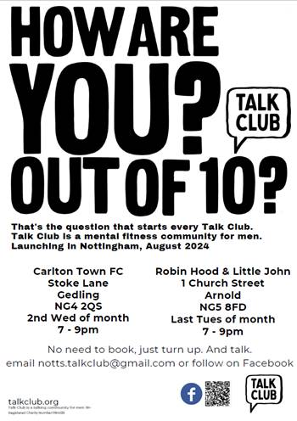  [www.talkclub.org](http://www.talkclub.org)

[Increasing Diversity of Inclusion within Co-production Tickets, Wed, Sep 4, 2024 at 2:00 PM | Eventbrite](https://www.eventbrite.co.uk/e/increasing-diversity-of-inclusion-within-co-production-tickets-979980828037?aff=ebemoffollowpublishemail&ref=eemail&utm_campaign=following_published_event&utm_content=follow_notification&utm_medium=email&utm_source=eventbrite)

[](Increasing%20Diversity%20of%20Inclusion%20within%20Co-production%20Tickets,%20Wed,%20Sep%204,%202024%20at%202:00%20PM%20|%20Eventbrite)

**This session will include drawing from the grassroots experience of national partners and sharing tips for increasing engagement.**

Learning from the Ageing Better programme and South Yorkshire Housing Association’s citizen led approach to ensuring that co-production is representative of the services, projects, and communities that it is intending to serve; this session will include drawing from the grassroots experience of national partners such as Ageing Better in Birmingham who represented a super diverse city. We will share tips for increasing engagement and learning from a tapestry of perspectives.

[Places Of Welcome - CUF](https://cuf.org.uk/places-of-welcome?fbclid=IwY2xjawEi03VleHRuA2FlbQIxMAABHSUM7FaPj3JRJ8H0HszW12Ry-35SzR4OgZT0vQVBcYtEWoW4qonMgwLSWA_aem_TkdTa9RvQGUnUnHOzD05uA)



[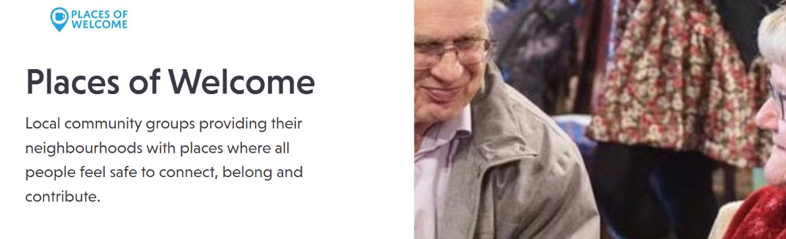](Places%20Of%20Welcome%20-%20CUF)[The Map - CUF](https://cuf.org.uk/places-of-welcome-map)

[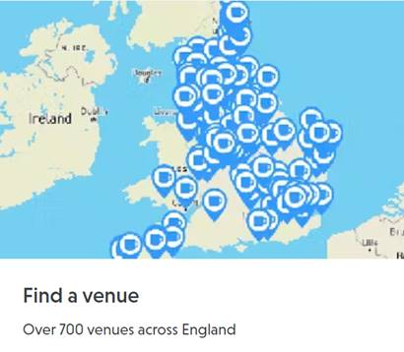](The%20Map%20-%20CUF)