Celebrating the 10th Anniversary of the
Museum of the Horse, Tuxford.
Did you know that the Museum of the Horse is all about our history? Everybody who travels in any form has connections with horse history. Many of our buildings are related to the horse. When you move house many of our well-known companies were formed with horses. Our clothing industry was connected to very early horse transport. Agriculture, industry, mining and of course military, were all connected to the history of the horse. Many of our sayings come from the world of the horse. Did you know ‘Crestfallen’, ‘Hobson’s Choice’ and ‘Dropped Off’ all come straight from the horse? If not, is it time you visited the Museum in Tuxford to find out more? From June, the Museum will be celebrating its 10th anniversary with events, exhibitions and family open days giving you the perfect opportunity to visit.
The Museum, situated in an old Posting House on the original old Great North Road in Tuxford, North Nottinghamshire was opened ten years ago in June 2014, by Sally Mitchell, better known for her art dealing, print publishing and the books she has written. Now almost 80, Sally created the Museum single handedly and it has won many accolades including a Heritage award, appeared on TV shows Bargain Hunt and Antiques Road Trip and has been hailed by The Club International D’Eperonnerie as one of the most comprehensive Horse museums in Europe. It appears on their website alongside such renowned museums as The Metropolitan in New York and the Hermes in Paris.
Sally commented: “Having visited the horse museums in Verden, Germany and Saumur in France, I thought it was a great shame that England, a great equestrian country, didn’t have a museum of the horse. It has the racing museum at Newmarket and the Royal Armouries in Leeds, which both have superb collections of a specialised area, none have the full history of the horse. The Museum of the Horse houses collections from 600 BC through Roman and Medieval times to the present day and covers items from many parts of the world. It has sections on North and South America, Africa and India, China and Tibet, Japan and Indonesia. It has dedicated sections on Coaching, Veterinary, Children’s items, Racing, Shoeing, Agriculture, Industry and Military. It is an amazingly comprehensive collection with many very rare items. I would challenge anyone to be able to say they had seen every item before. People are amazed at the diversity and size of the collections. Nine rooms and nearly two thousand items on show.”
The Museum is a collection for all ages. Recently a little girl of seven wrote in the visitor’s book: “The best and most interesting thing in the world!” Older visitors say how they are reminded of things they saw in their youth. It really is a collection to intrigue anyone with an interest in history and curiosities.
The Museum produces talks, on-line and in-house and is also an ideal place for group visits which can be booked by appointment. A fascinating curious objects quiz in which items can be handled and your knowledge challenged, can be arranged. With its own spacious car park behind the museum and a coffee shop in the courtyard offering delicious light lunches and cream teas with homemade cakes, it is a lovely way to spend a few hours. In the summer there is a delightful courtyard, overlooked by the Museum’s Mail Coach, where you can sit for lunch or just a coffee. There is also the internationally known Sally Mitchell art gallery on the floor below the museum with animal and country themed paintings, prints and cards.
As part of the 10th anniversary celebrations, the Museum will be holding an exhibition of recent acquisitions to the collection from 9th June to the end of August. The anniversary opening is taking place on Sunday 9th June 2pm – 4.00pm with the Museum open 6 days a week 9.30am – 4.00pm Monday – Friday and 9.30am – 1.30pm Saturdays. From 9th – 15th September there will be a Heritage Open Day event with a Coaching exhibition of the history of our roads and of our coaching town, Tuxford, accompanied by talks. For more information visit the website www.museumofthehorse.co.uk or follow us on Facebook, Pinterest or Instagram, ‘Museum of the Horse’. Entry is free but donations are very much appreciated as the museum has no outside funding.
Ends

For more information, please contact:
Media Enquiries Suzanne Alexander suzanne@dogart.com
Museum Enquiries Sally Mitchell sally@dogart.com
Tel: 01777 838234

Museum of the Horse, The Newcastle Arms, 1 Market Place, Tuxford, Nottinghamshire, NG22 0LA.
www.museumofthehorse.co.uk

03.04.2024

Images attached as separate files. If you need any higher resolution images, please contact us and we would be happy to send these. Email: suzanne@dogart.com

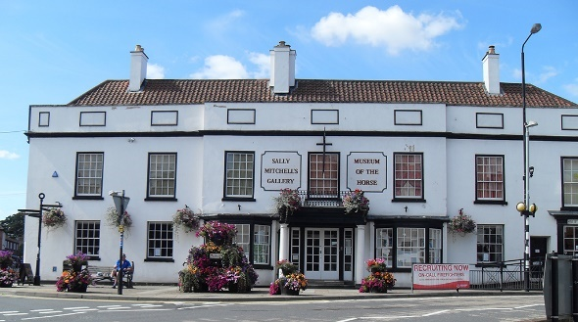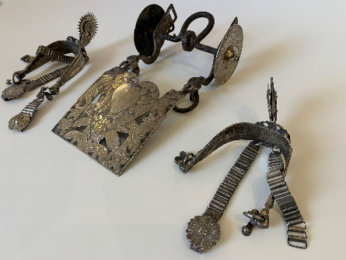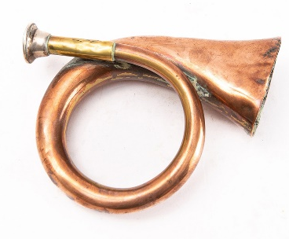
Rare 18thC Hunting Horn made by Wigley of London.
Silver South American Bit with
matching Spurs.
The Museum of the Horse, Tuxford.

Continued…
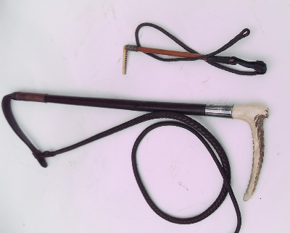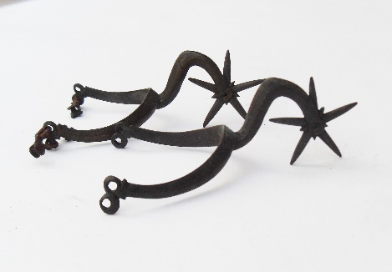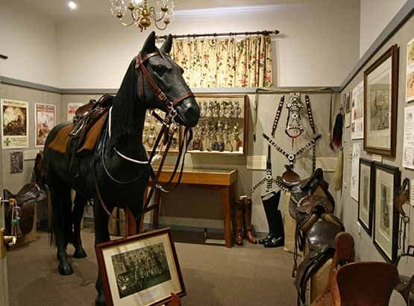
Christening whip, often given as presents during Victorian times.
Rare pair of bronze spurs. Late 16thC or early 17thC.
One of nine rooms at the Museum.

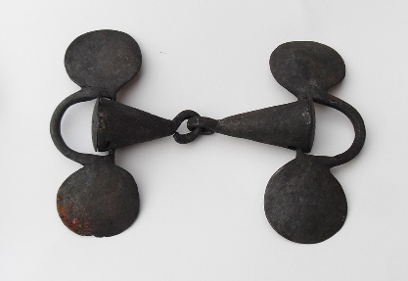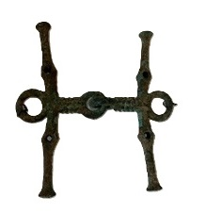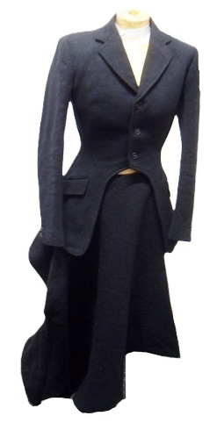
Rare Bronze Bit 7th-4thC BC.
Side Saddle Habit circa 1890.
Rare Early Snaffle 15th Century.
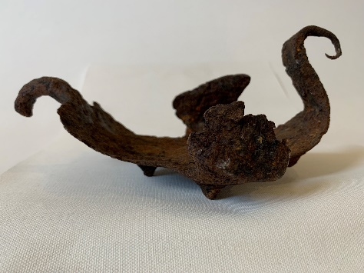
Rare Roman Hippo Sandal. The Hippo sandal was the Roman’s first attempt to make iron shoes for horses. They were trying to emulate the rush slipper that was the only horseshoe in use at the time. After all, it would have been an odd person who would think you could nail something onto a living creature! This sandal is particularly rare because it has studs formed into the sole of the shoe. They were probably the first studs ever used and would have been to prevent the horse slipping on the paved roads.

