May
Social media posts
Mental Health Awareness Week (13 – 19 May)
It’s #mentalhealthawareness week and this year the theme is ‘Movement: Moving more for our mental health’. Did you know @DCCPublicHealth offer a free 12-week physical activity service? Find out more here: https://www.livelifebetterderbyshire.org.uk/services/getting-active/getting-active.aspx
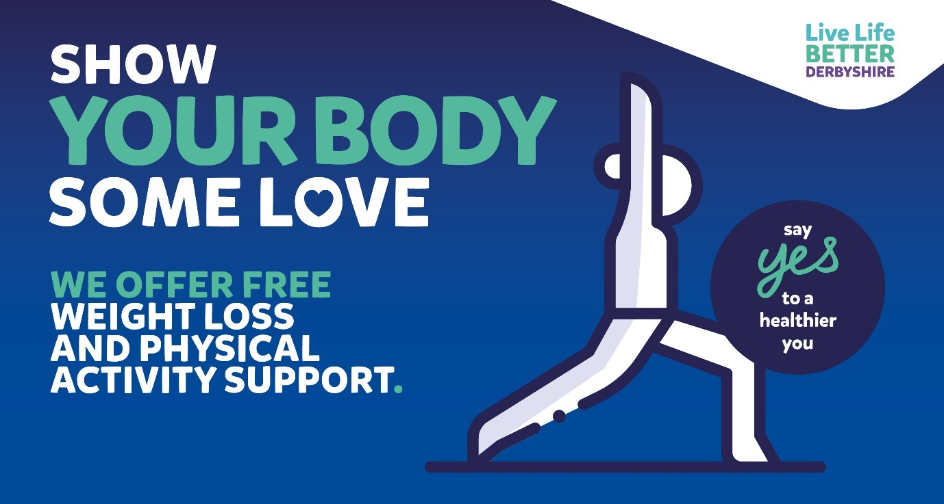
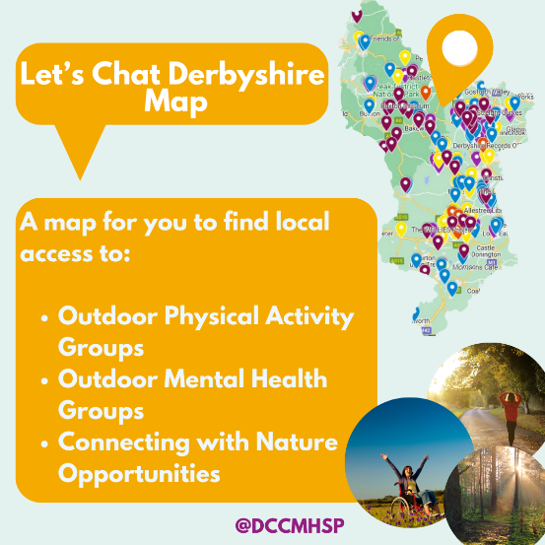
It’s #mentalhealthawareness week, and this year the theme is movement. Derbyshire Mental Health and Suicide Prevention team’s Let’s Chat map shows outdoor activity sessions and groups across Derbyshire. You can search for activities close to you on the map here.
Find free and low-cost opportunities to connect with nature across Derbyshire including beauty spots, walks, parks and so much more. Visit @DCCMHSP Let’s Chat Derbyshire Map for locations and information. https://bit.ly/MHPAMap

Getting physically active can help improve your mental wellbeing. Across Derbyshire, there are lots of opportunities to take part in in outdoor exercise, from joining a group to exploring nature. Check out @DCCMHSP Let's Chat Derbyshire Map for locations here

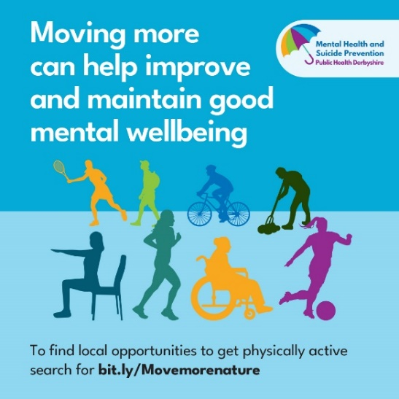
Transform your wellbeing by moving more! Moving more
isn't just good for the body, it's a great for your mental health
too. Check out free local groups via
the Let's Chat Derbyshire map
and help improve your mental wellbeing and health today.
#letschatderbyshire @DCCMHSP

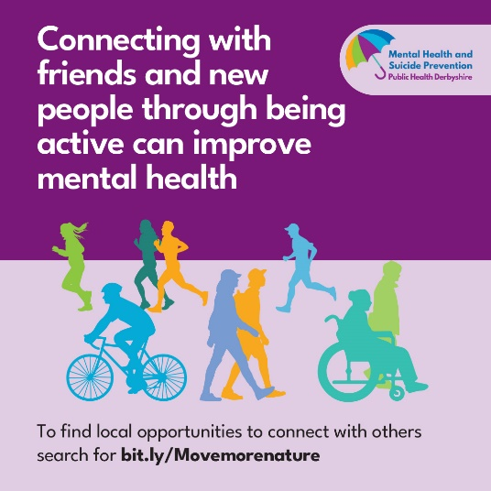
Feeling low? Getting active can be a great way of meeting new friends. A double boost for your mental health! Ready to get connected? Meeting new people can help improve your mental health for more information visit www.bit.ly/Movemorenature #leschatderbyshire @DCCMHSP

This year's Mental Health Awareness Week theme is all about moving more and there's lots of apps to help to get a bit more active. Why not try the NHS Couch to 5K app. Download it here: https://derbyshire.orchahealth.com/en-GB/app/nhs-couch-to-5k/823cbb03-2ff6-46ad-8a63-99a5c32af3d6
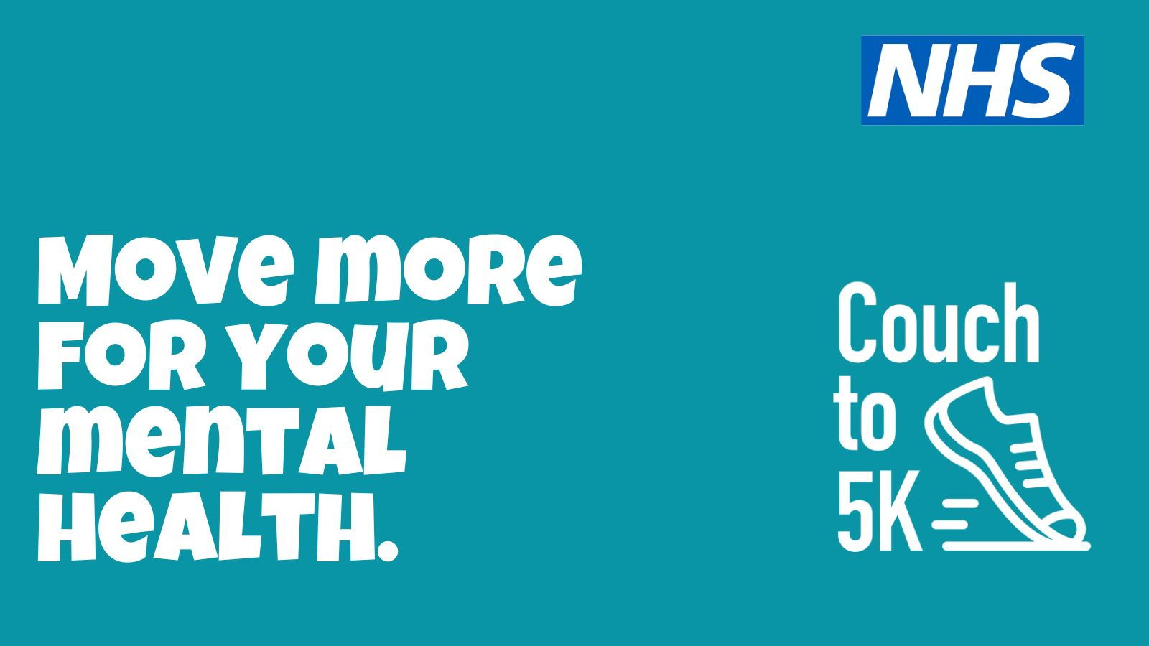
This year's Mental Health Awareness Week theme is 'Movement: Moving more for our mental health' and the NHS Active Ten app can help you track how much walking you're doing. Download it here: https://derbyshire.orchahealth.com/en-GB/app/nhs-active-10-walking-tracker/2eb35efe-cf9b-44cd-8b97-ae8ad59f5b12
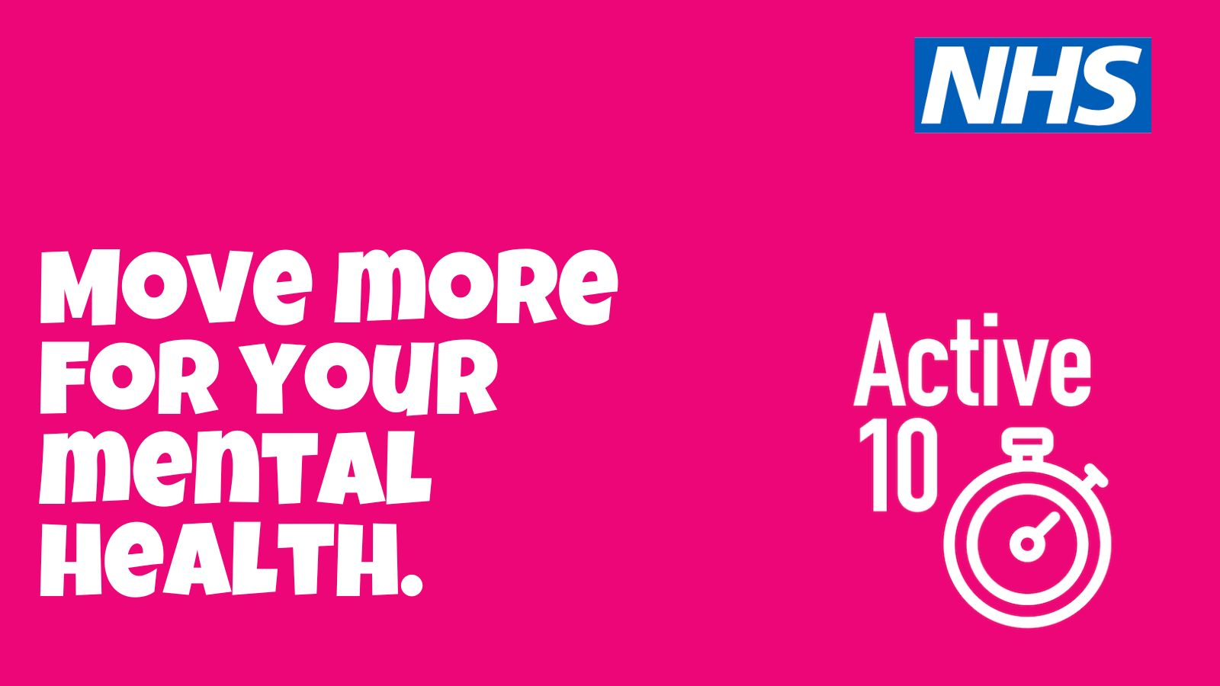
Healthier Futures
If you’re a parent or carer of children aged 0 – 12 and would like some help to get you and your family healthier, then find out about our free Healthier Futures service. https://www.livelifebetterderbyshire.org.uk/services/family-health/healthier-futures.aspx
Calling all Derbyshire parents and carers – have you heard about Healthier Futures? It’s a free family support service to help you and your loved ones on the path to a healthier future. Find out more here: https://www.livelifebetterderbyshire.org.uk/services/family-health/healthier-futures.aspx

World No Tobacco Day (May 31st)
It's #WorldNoTobacco Day. If you're ready to #quit for good, then check out #LiveLifeBetterDerbyshire a FREE healthy lifestyles service. Find out more here: www.livelifebetterderbyshire.org.uk/stopsmoking
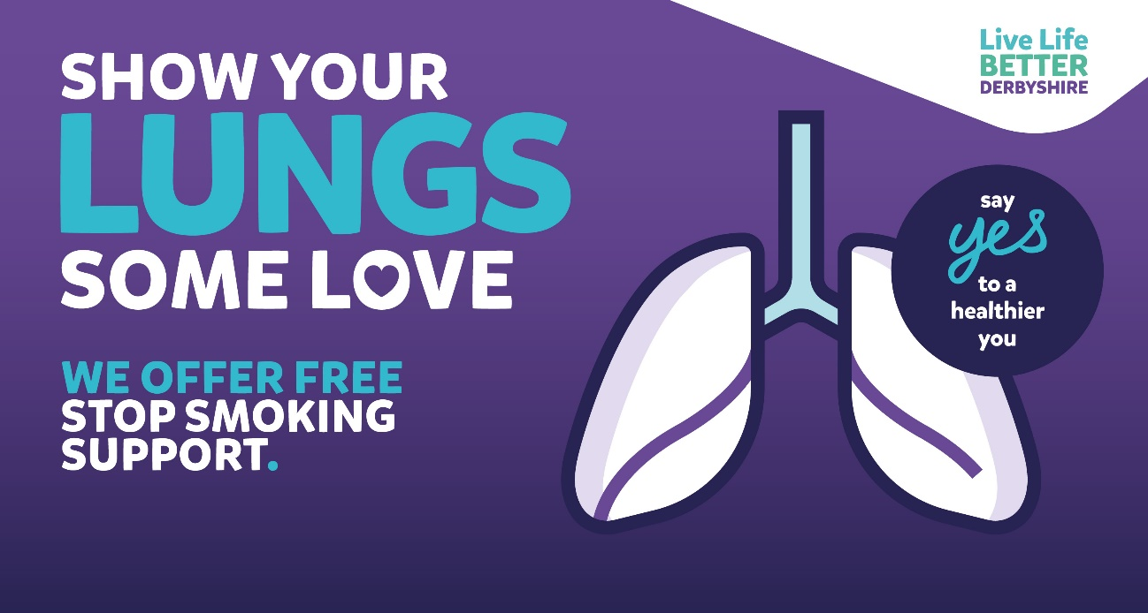

It's #WorldNoTobacco Day. Live Life Better Derbyshire offers FREE support to help everyone #quit for good. Find out more online here: www.livelifebetterderbyshire.org.uk/stopsmoking

If you’re ready to quit for good on World No Tobacco Day, then there are some quality assured stop smoking apps that can help. Visit derbyshire.orchahealth.com and search for ‘smoking’
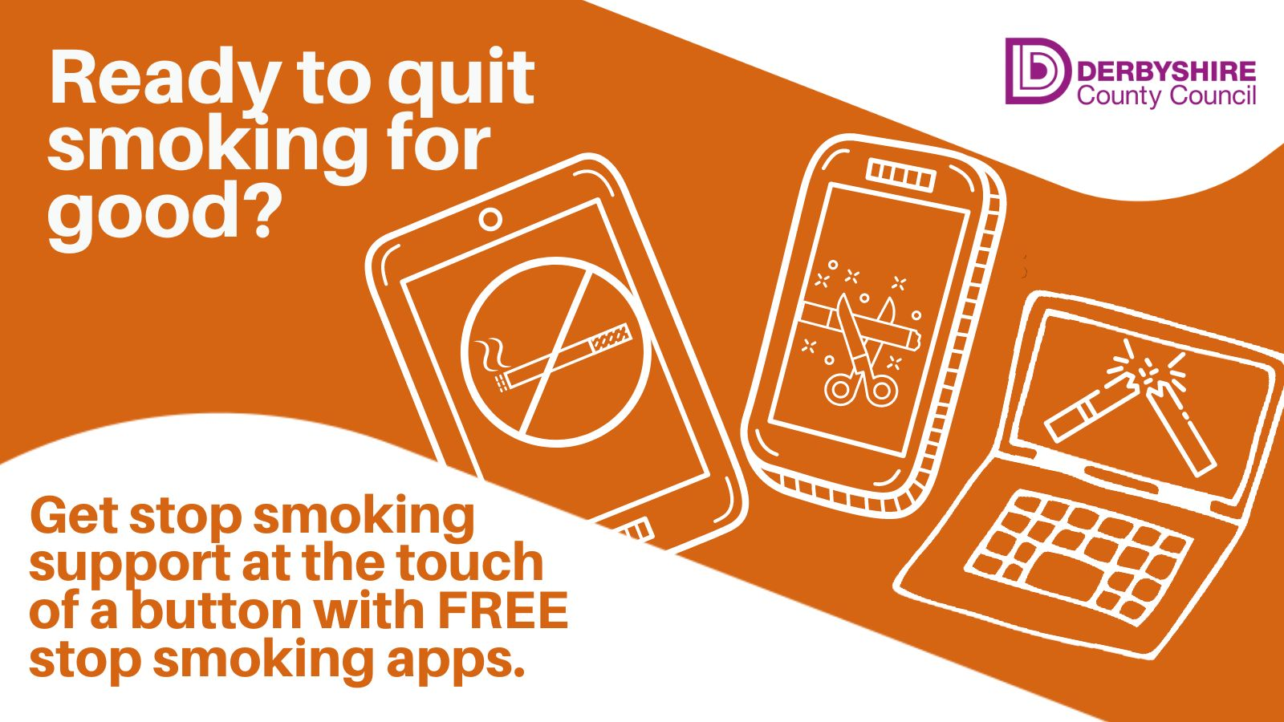

National Smile Month (May 13th – June 13th)
All of our children’s oral health campaign assets including posters, leaflets, suggested social media copy and social media images can be downloaded here

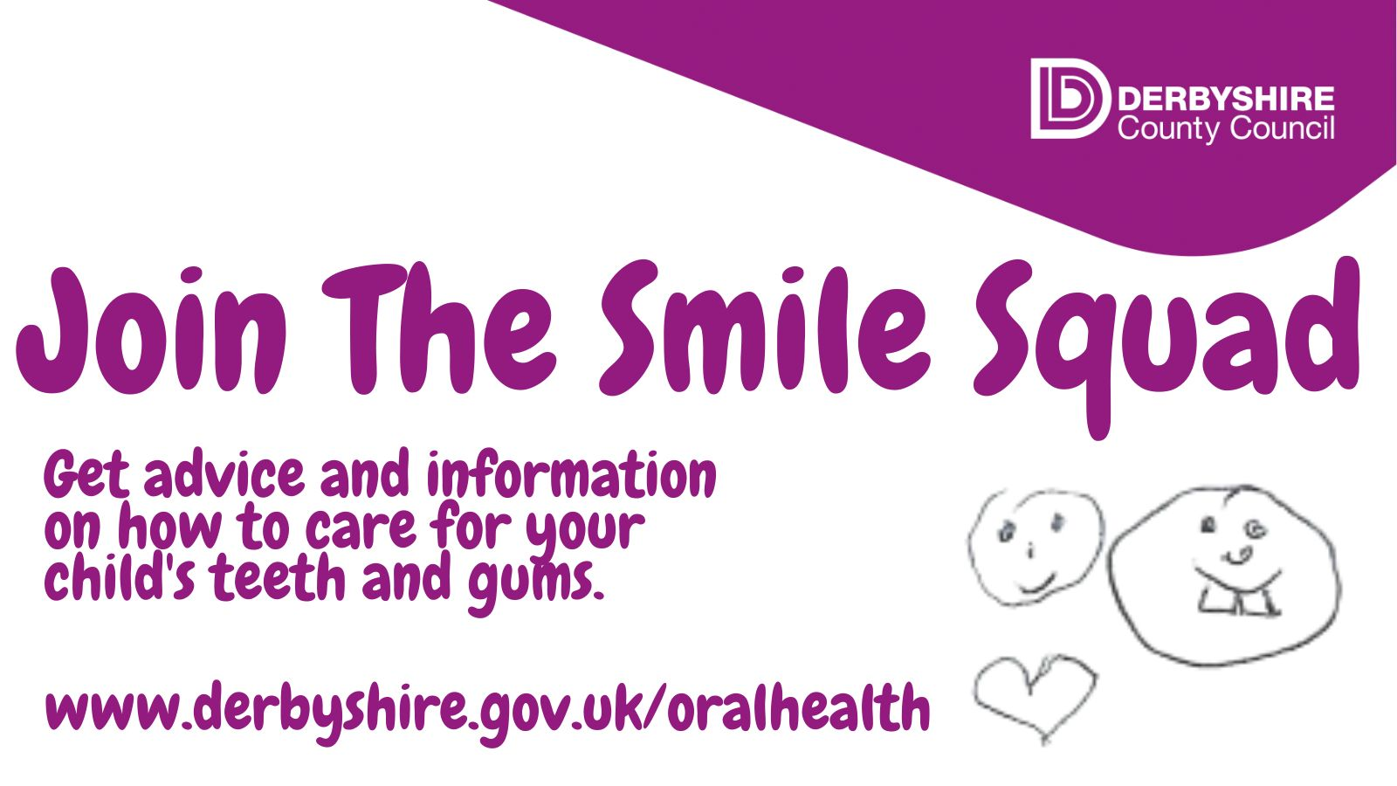
Do you want to get some advice about how to care for your little one’s teeth and gums during #NationalSmile month? Follow us and join our #smilesquad Find out more at www.derbyshire.gov.uk/oralhealth

It’s National #Smile Month and over the next few weeks we’ll be sharing tips and advice about how to keep your child’s teeth in top condition. Even the most dedicated brushers might learn a thing or two! #letstalkteeth www.derbyshire.gov.uk/oralhealth #smilesquad
It’s National Smile Month and over the next few weeks we’ll be sharing tips and advice about how to keep your child’s teeth in top condition. Plus you can sign up to receive email top tips for caring for your teeth here.
You can also download national Oral Health Foundation Smile Month assets here: www.dentalhealth.org/smilemonthdownloads
Exam season (GCSEs, A levels and AS levels run May 9 – June 25)
If you, or someone you know, are studying for exams right now then it can be a challenging and stressful time. Kooth offers free, anonymous support and you can download their handy app here: https://derbyshire.orchahealth.com/en-GB/app/kooth/2d8ed883-6cb8-4d4c-87f1-
69f52def531c
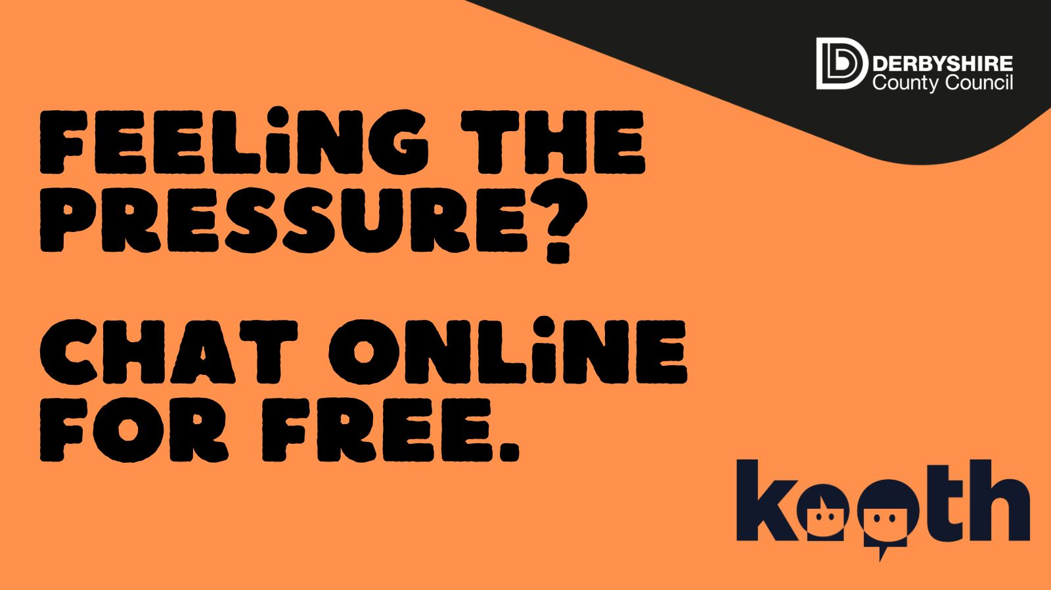

Newsletter / intranet / payslip letter messaging
Mental Health Awareness week (May 15th – 21st)
It's Mental Health awareness week and this year it's all about Movement: Moving more for our mental health

Exam time can be hard, and it can feel relentless. If you, or someone you know, are struggling then Kooth offers free, anonymous support and you can download their handy app here: https://derbyshire.orchahealth.com/en-GB/app/kooth/2d8ed883-6cb8-4d4c-87f1-69f52def531c

Newsletter
Mental Health Awareness Week runs from 13 – 19 May and this year’s theme is ‘Movement: Moving more for our mental health’.
Being active is important for our mental health. But so many of us struggle to get enough exercise.
We know there are many different reasons for this, so this Mental Health Awareness Week we want to help people to find moments for movement in their daily routines.
Going for a walk in your neighbourhood, putting on your favourite music and dancing around the living room, chair exercises when you’re watching television – it all counts!
Did you know that Derbyshire County Council offers a free 12-week physical activity service. Find out more at www.livelifebetterderbyshire.org.uk/gettingactive
You can also download health and wellbeing apps like Coach to 5k from our quality assured apps library here: derbyshire.orchahealth.com
If you, or someone you know, is struggling with their mental health then the Derbyshire Mental Health helpline is open 24/7 on 0800 028 0077.

