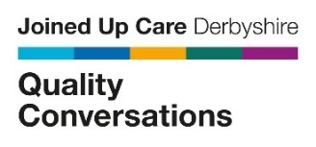
Quality Conversations Masterclasses

Do you want to refresh and develop your Quality Conversation skills?
Try these 1-hour masterclass sessions!

- Practice your skills with the support of an experienced trainer.
- Learn ways to manage conversations you’re finding challenging.
- Learn from other colleagues, and share best practice.

Who can book:

- Joined Up Care Derbyshire staff members who have already attended the Core Quality Conversation training.

What to expect:
- Facilitated session –share experiences and work together to support each other in using Quality Conversation skills effectively.
- Interactive session - we want to hear from you so please have a working camera and microphone!
- A safe space - to allow everyone to get involved.
- Networking - meet and collaborate with like-minded colleagues.
Day | Date | Start | Finish | Session focus
Wednesday | 03.04.24 | 11.30am | 12.30pm | Listening Skills- book here
Wednesday | 03.04.24 | 15:30 | 16:30 | Push and Pull Communications- book here
Tuesday | 09.04.24 | 11.30 | 12.30 | Asking effective questions- book here
Tuesday | 09.04.24 | 15:30 | 16:30 | Push and Pull Communications- book here

Quality Conversations Masterclass training dates April 2024

