Brightlife Champion Against Loneliness Awards 2024
Congratulations to the winners of the Champions Against Loneliness Awards which were awarded to all very deserving winners on Saturday 16th March 2024.
Bolsover District did very well:
Special congratulations to Tracey Robinson of Bolsover Memory Café, Hillstown Village Hall who Debbie Fennell, Bolsover CVS nominated and scooped the Volunteer Champion Against Loneliness Award for her work coordinating the team and personal dedication to the group
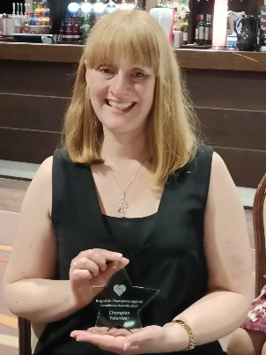
Tracey Robinson, winner of the Volunteer Champion Against Loneliness Award
Tracey being presented with her award by Debbie Fennell, Community Connections Coordinator and Group Development, Bolsover CVS
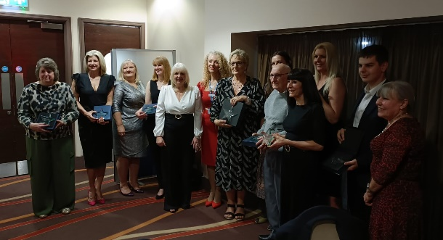
The award winners and nominators

