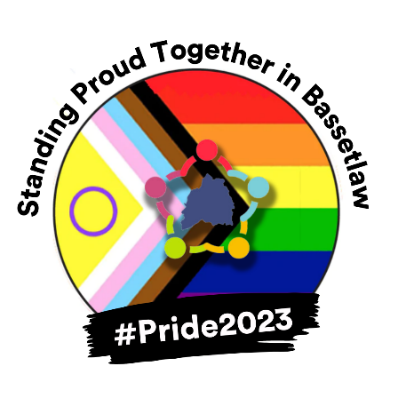

BCVS 2023 Pride Quiz Answers

Name ____________________________________________________________________

1.
2.
3.
4.
5.
6.
7.
8.
9.
10.
11.
12.

Total Correct Answers:

