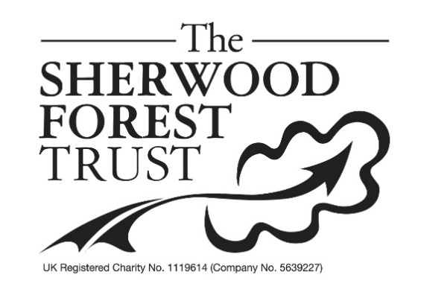
PRESS RELEASE

Major Fun In The Forest
The popular Major Oak Woodland Festival – a celebration of woodlands, nature and traditional crafts - returns to Sherwood Forest’s leafy glades this June 17th and 18th 2023.
Green woodworkers, nature inspired garments and prints, blacksmiths, local charities, historical games and re-enactors are amongst the many woody wonders to see, and – in some cases – try yourself! From children’s storytellers to The Wild Man of the Woods, you never know who you might meet in Robin Hood’s traditional haunts.
The festival takes place outdoors in the woodland adjoining the Sherwood Forest Visitor Centre, including around the famous Major Oak. It has been organised by Sherwood Forest Trust, a Nottinghamshire charity focussed on nature conservation and local heritage, by permission of the RSPB, who look after the site.
Patrick Candler, Chief Executive of the Sherwood Forest Trust said, ‘This is an event for the whole family, outdoors in the wonderful setting of Sherwood Forest, so we hope as many people as possible will come and enjoy a midsummer weekend in the greenwood’.
Admission to the Major Oak Woodland Festival is free. Car parking costs £5 all day. Refreshments are available at the Sherwood Forest Visitor Centre.

Ends
Information for editors
The Major Oak Woodland Festival takes place in woodland adjoining Sherwood Forest Visitor Centre, Edwinstowe, Notts, NG21 9RN. It is organised by the Sherwood Forest Trust charity (www.sherwoodforest.org.uk). The woodland site and the Sherwood Forest Visitor Centre is managed by the RSPB.
For more details, contact Katie Doull 01623 821490, katie.doull@sherwoodforesttrust.org.uk

