May
Social media posts
Mental Health Awareness Week (15th – 21st May)
It’s #mentalhealthawareness week and this year the theme is #anxiety and how we can help to manage it. Get information and support here: https://www.nhs.uk/mental-health/conditions/generalised-anxiety-disorder/overview/
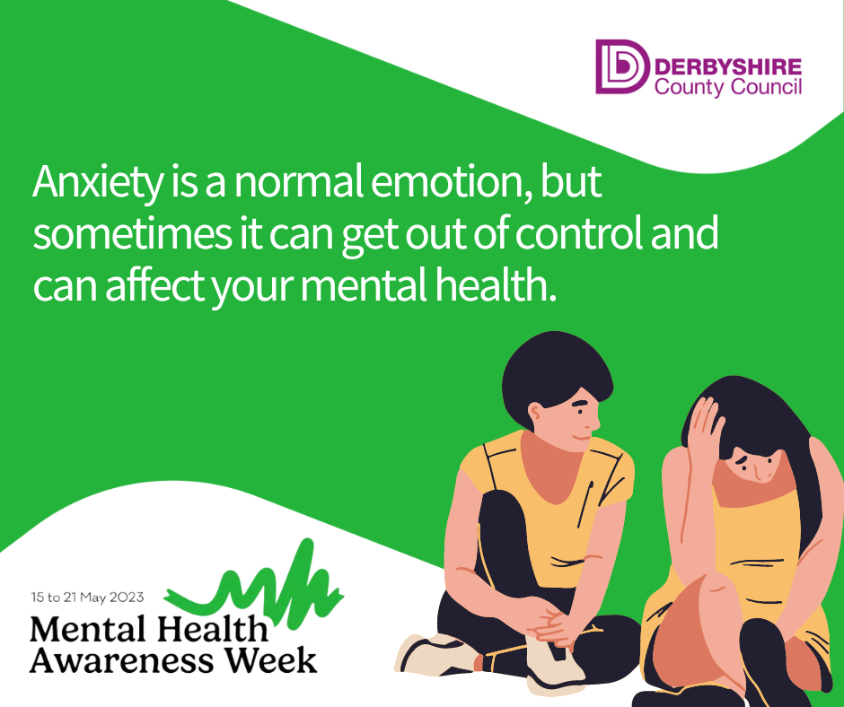
Anxiety is a normal emotion, but sometimes it can get out of control and become a problem. Find out more about how to get support if your anxiety is becoming hard to manage. https://www.nhs.uk/mental-health/conditions/generalised-anxiety-disorder/overview/
Lots of us will feel #anxious at some point, but if you are feeling anxiety regularly then it can become a problem. Find out more from @MindCharity: https://www.mind.org.uk/information-support/types-of-mental-health-problems/anxiety-and-panic-attacks/about-anxiety/
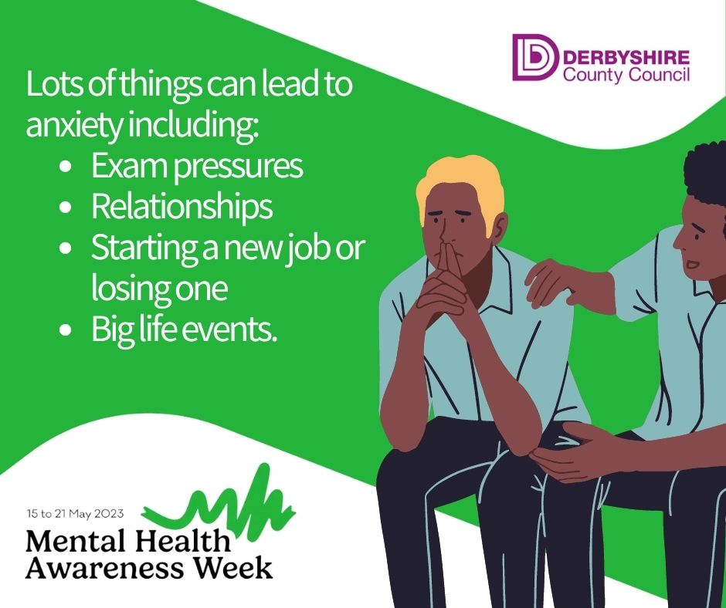
Feeling anxious? Take a moment to stop and breathe. Breathe in and out for 10 seconds, repeat till you feel calmer. There’s more support on dealing with #anxiety online https://www.nhs.uk/mental-health/conditions/generalised-anxiety-disorder/self-help/
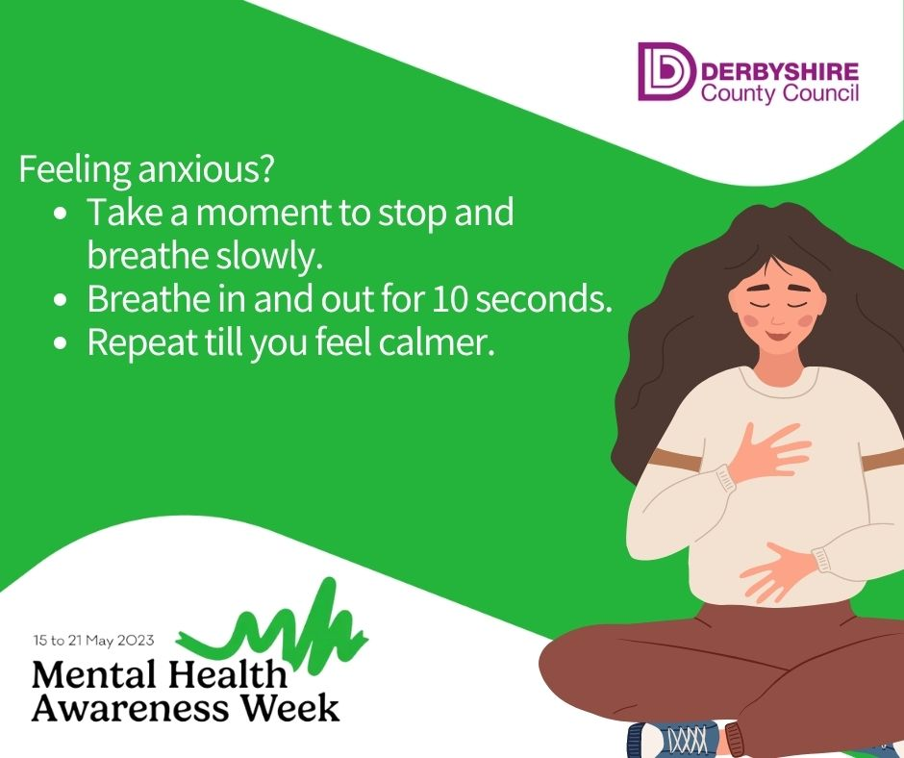

If you’re feeling #anxious a lot of the time, then it can help to speak to someone. The Derbyshire Mental Health helpline is open 24/7 on 0800 028 0077
World No Tobacco Day (May 31st)
It's #WorldNoTobacco Day. If you're ready to #quit for good, then check out #LiveLifeBetterDerbyshire a FREE healthy lifestyles service. Find out more here: www.livelifebetterderbyshire.org.uk/stopsmoking
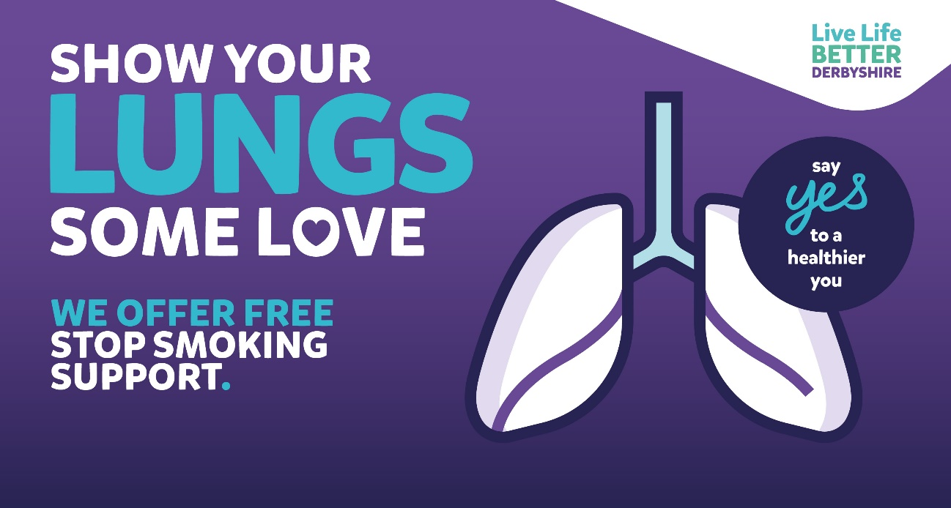

It's #WorldNoTobacco Day. Live Life Better Derbyshire offers FREE support to help everyone #quit for good. Find out more online here: www.livelifebetterderbyshire.org.uk/stopsmoking

It's #WorldNoTobacco Day. If you'd like a little extra help to quit smoking for good then why not download our My Quit Route app. Stop smoking support direct to your phone. Search for it here: https://derbyshire.orcha.co.uk/defaultsearch/?search=my%20quit%20route

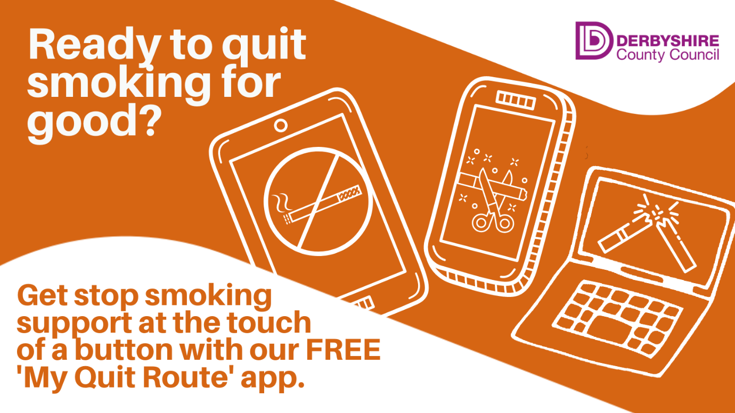

National Smile Month (May 15th – June 15th)
Do you want to get some advice about how to care for your little one’s teeth and gums during #NationalSmile month? Follow us and join our #smilesquad - special thanks to Evie, aged 6 from Chesterfield for her fantastic doodle :) Find out more at www.derbyshire.gov.uk/oralhealth
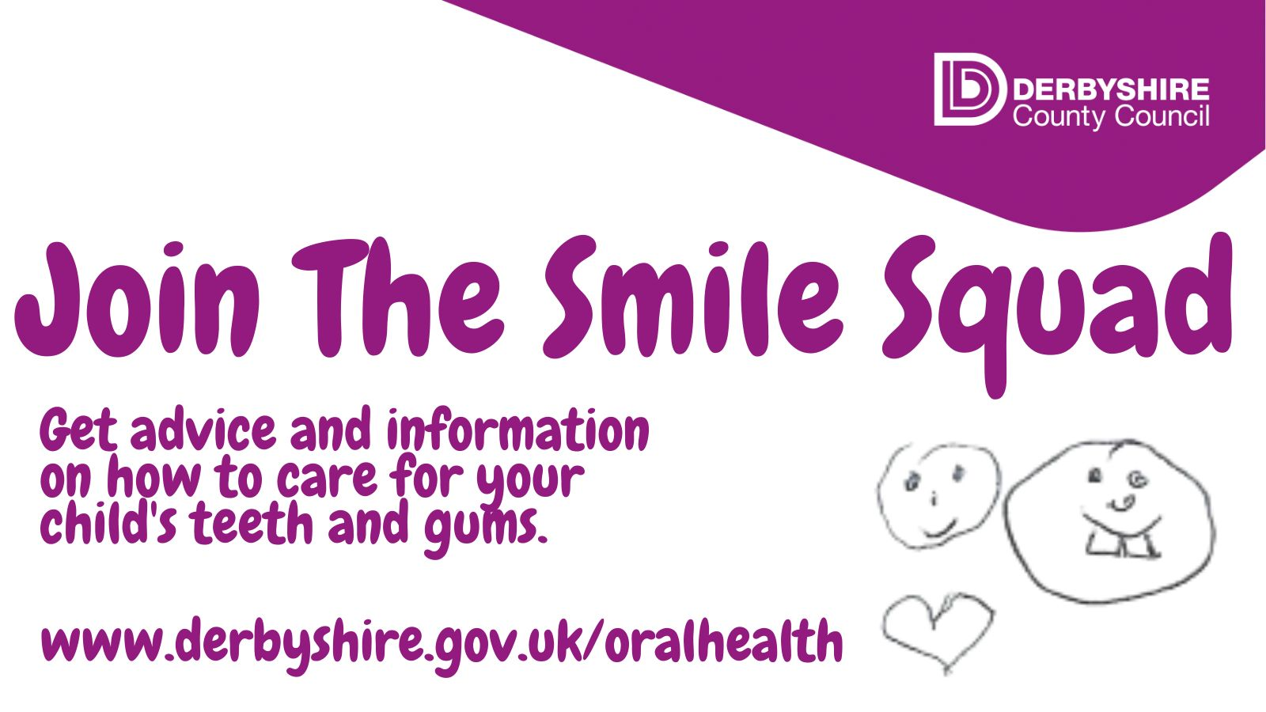
Post for FRI 13 MAY. On Monday 15th of May the Great British Brushathon will connect people from all around the world in one giant communal brushing event. Take a selfie while brushing your teeth and post it to social media. Don’t forget to include #GreatBritishBrushathon and copy us in @DCCpublichealth so we can admire your brush work 😊
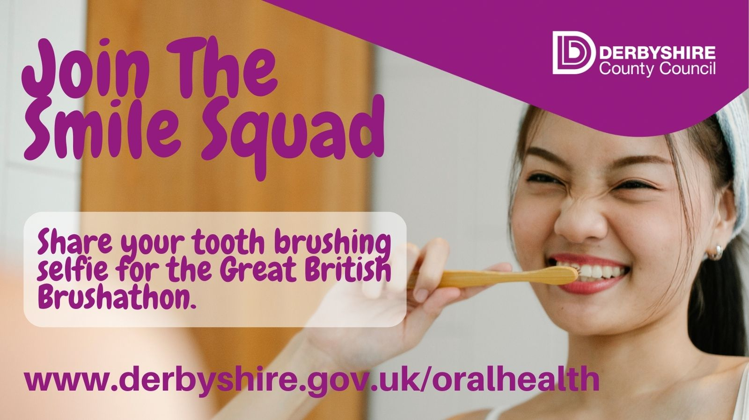
Post for MON 15 MAY Today kicks off #NationalSmileMonth and to mark the event The Great British Brushathon will connect the world in one giant communal brushing event. Why not take a selfie while brushing your teeth & post it to social media? Don’t forget to include #GreatBritishBrushathon @DCCpublichealth and show the world your technique 😊
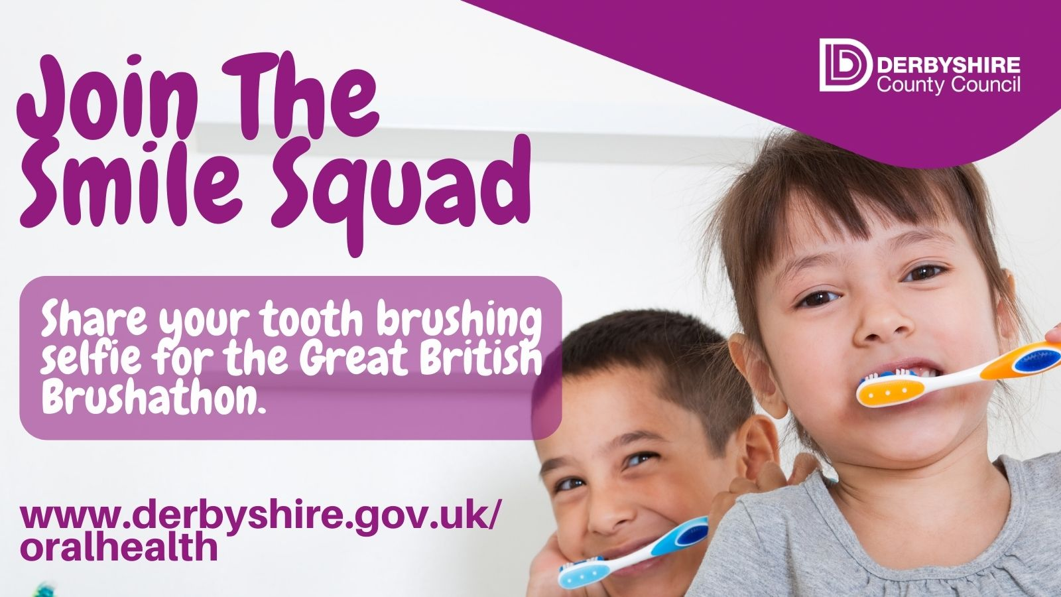

It’s National #Smile Month and over the next few weeks we’ll be sharing tips and advice about how to keep your child’s teeth in top condition. Even the most dedicated brushers might learn a thing or two! #letstalkteeth www.derbyshire.gov.uk/oralhealth #smilesquad
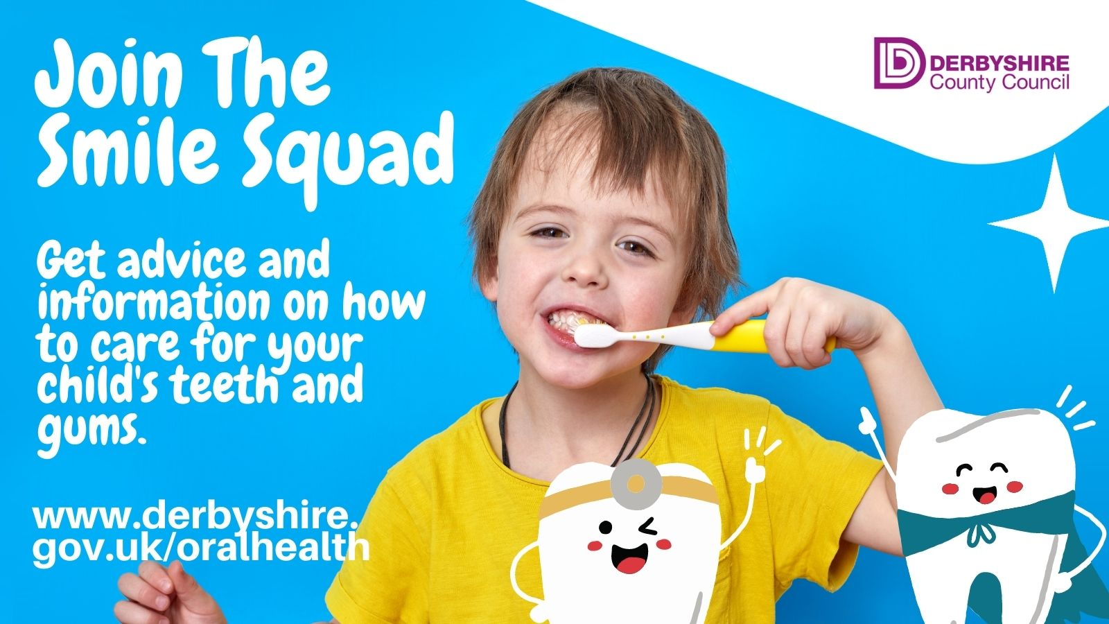
All of our children’s oral health campaign assets including posters, leaflets, suggested social media copy and social media images can be downloaded here: https://drive.google.com/drive/u/0/folders/1lGNxIf_CpcxodhKRtF97mjKfUOLkMFee
Please feel free to use and share widely from May 15th onwards.
Newsletter / intranet / payslip letter messaging
Mental Health Awareness week (May 15th – 21st)
It's Mental Health awareness week and this year it's all about anxiety and how to deal with it.
Anxiety is a natural human response when we feel under threat. You can experience it through thoughts, feelings and physical sensations.
Symptoms of anxiety vary but can include:
- Feeling restless or worried
- Difficulty to concentrate or sleep
- Dizziness
- Heart palpitations.
There are a few self-care tips if you are feeling anxious: Talk to someone you trust, keep a diary of how you feel, try to manage your worries, and try to get a bit more active.
While feelings of anxiety at times are completely normal, please speak to someone if anxiety is affecting your daily life or causing you distress.
If you or your loved one are experiencing distress or anxiety, or feeling that you cannot cope, the Derbyshire Mental Health helpline can be called 24/7 on 0800 028 0077
Get more advice around anxiety on the NHS website.

