March
Social media posts
Vision screening for children – ongoing
Take your child for a free NHS sight test when they start school. NHS sight tests are free for children under 16 years old and can pick up any vision and sight problems early. Find out more: https://derbyshirefamilyhealthservice.nhs.uk/our-services/0-5-years/pre-school-3-5-years/toddler-health-and-wellbeing/vision
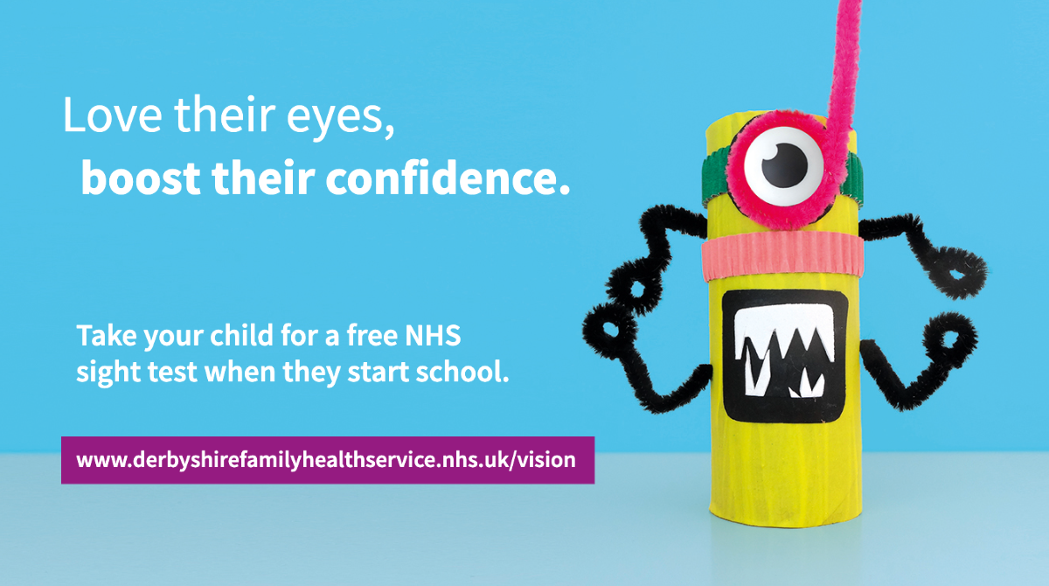
Your child might not know they have a problem with their eyes so it’s vital to get a FREE NHS sight test when your child starts school. They don’t need to be able to read to get their vision checked. Find out more: https://derbyshirefamilyhealthservice.nhs.uk/our-services/0-5-years/pre-school-3-5-years/toddler-health-and-wellbeing/vision
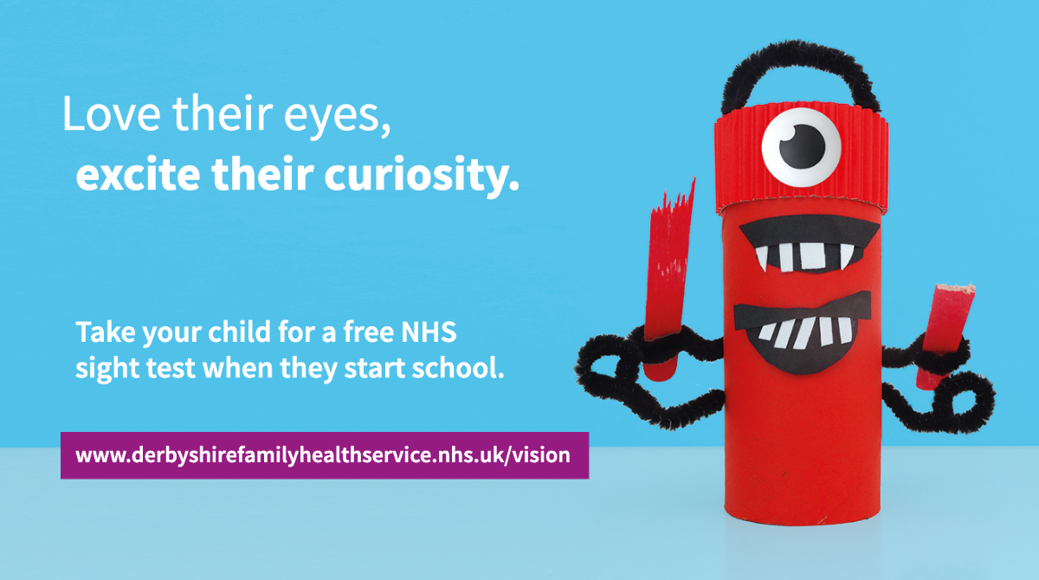

No Smoking Day 8th March
It's national #NoSmoking day and if you're ready to #quit then why not give your local, FREE, Live Life Better Derbyshire service a call? 0800 085 2299 or visit www.livelifebetterderbyshire.org.uk
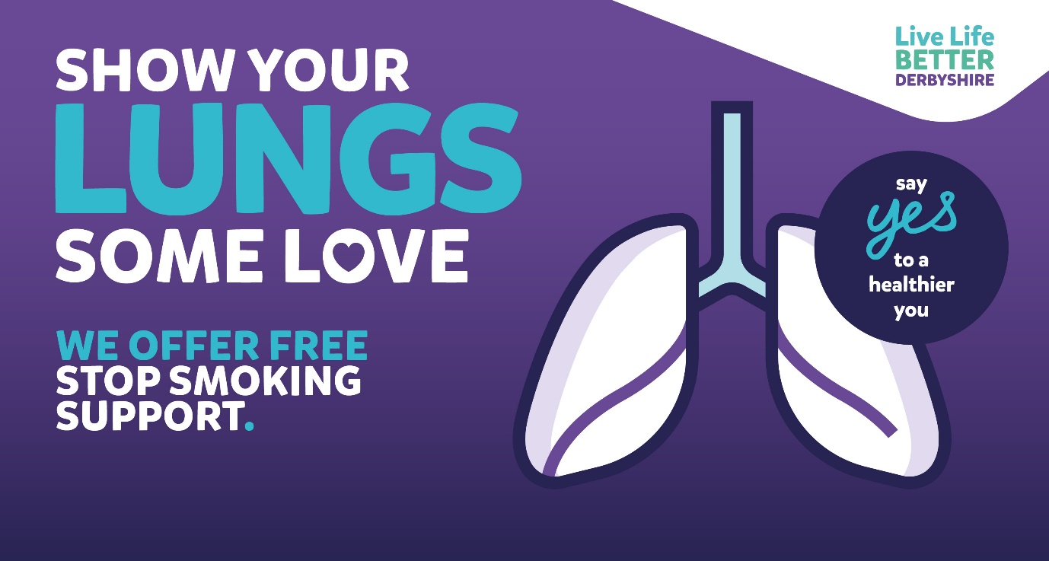
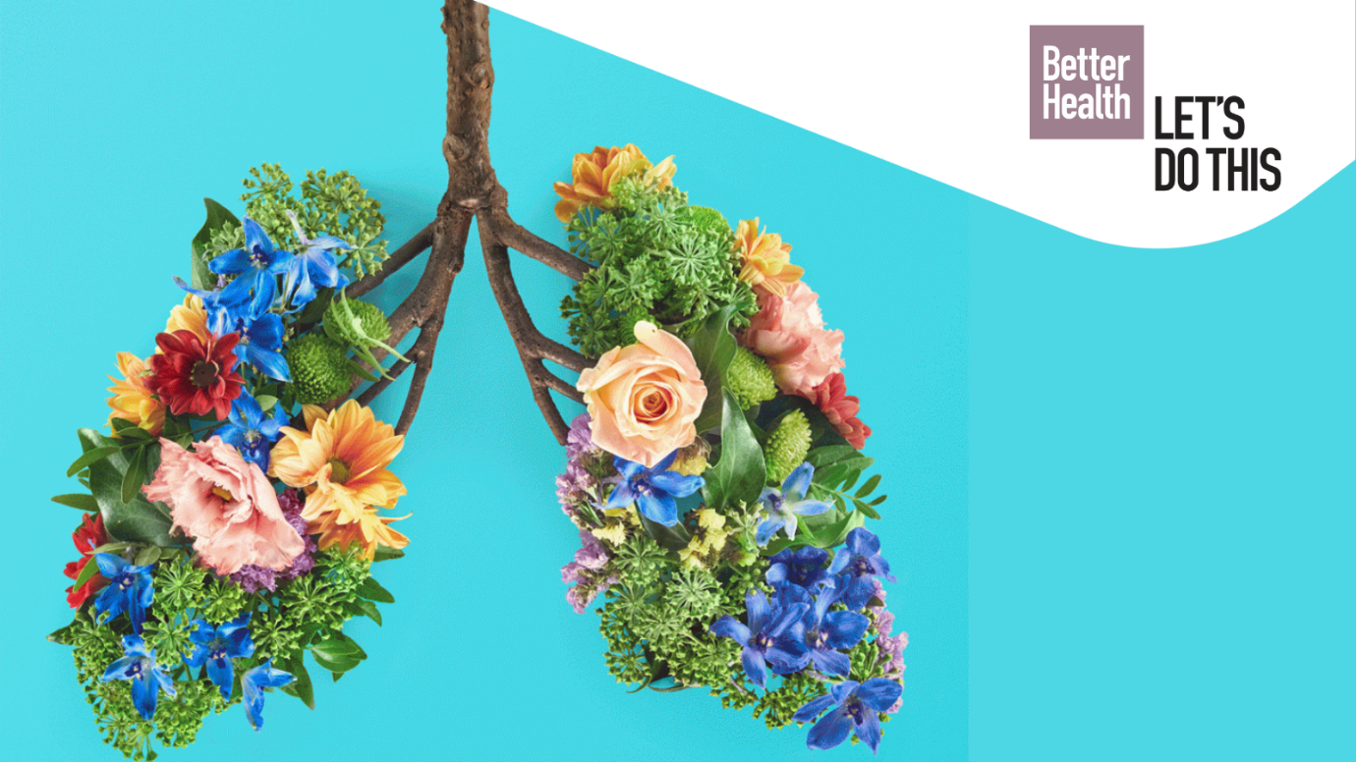
Ready to #quit for good during #NoSmoking day? Get top tips and support from @NHS #Smokefree here https://www.nhs.uk/smokefree
Ready to #quit for good during #NoSmoking day? Get in touch with Live Life Better Derbyshire, your FREE, local #stopsmoking service. Call 0800 085 2299 or visit www.livelifebetterderbyshire.org.uk
It's National #NoSmoking day and if you're ready to quit for good then why not download @DCCPublichealth FREE My Quit Route app? Full of useful support to help you stop for good, Download it here: https://derbyshire.orcha.co.uk/defaultsearch/?search=my%20quit%20route
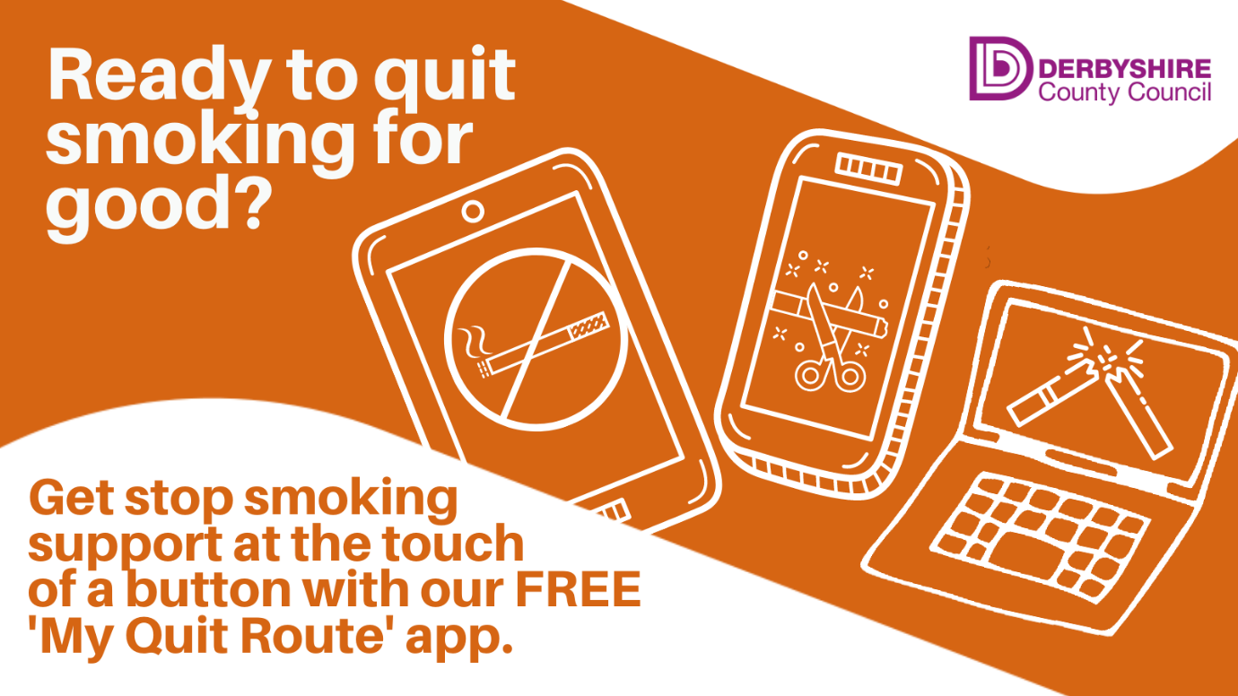

Self-Harm Awareness Day 1st March
It’s National Self-Harm Awareness Day on March 1st and if you need support around this issue then @Harmless provides support, information & training. Find out more about their work at www.harmless.org.uk

Harmless is leading the national #SelfHarm Awareness Day campaign on March 1st, which seeks to shine a light on self-harm and de-stigmatize this often-misunderstood issue. Find out more about their work at www.harmless.org.uk
Ovarian Cancer Awareness Month
It's #OvarianCancer awareness month. Learn more about the signs and symptoms online here: https://www.cancerresearchuk.org/about-cancer/ovarian-cancer/symptoms
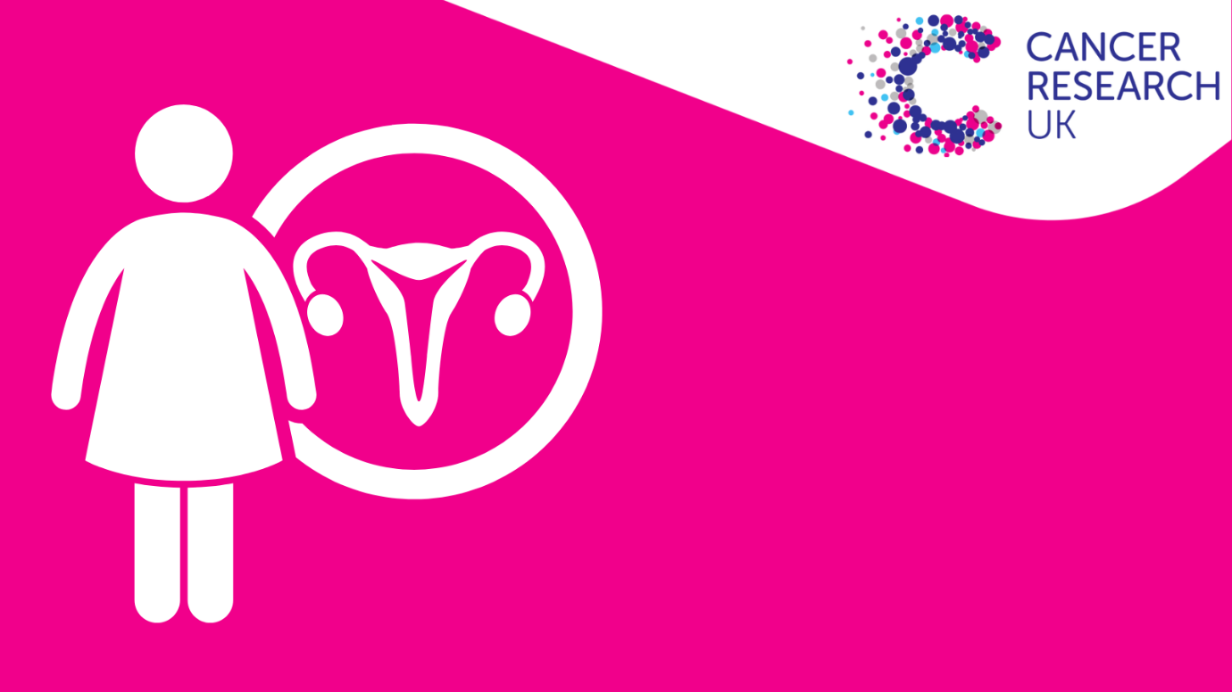
During #OvarianCancer month find all the facts and figures about the disease here: https://targetovariancancer.org.uk/
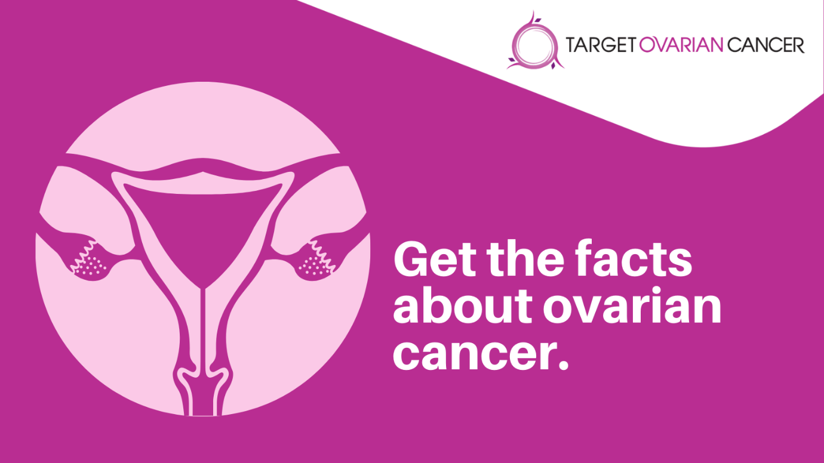

Each year 7,400 woman are diagnosed with #ovariancancer in the UK. Find out more about the risk factors online here: https://targetovariancancer.org.uk/about-ovarian-cancer/risk

Prostate Cancer Awareness Month
It’s #ProstateCancer Awareness month & 1 in 8 men will get prostate cancer. If you’re aged over 50, if you are of black ethnicity, or your dad or brother had it, you’re at even higher risk. Find out more at https://prostatecanceruk.org/
Prostate cancer is not always life-threatening. But when it is, the earlier you catch it the more likely it is to be cured. Visit https://prostatecanceruk.org/
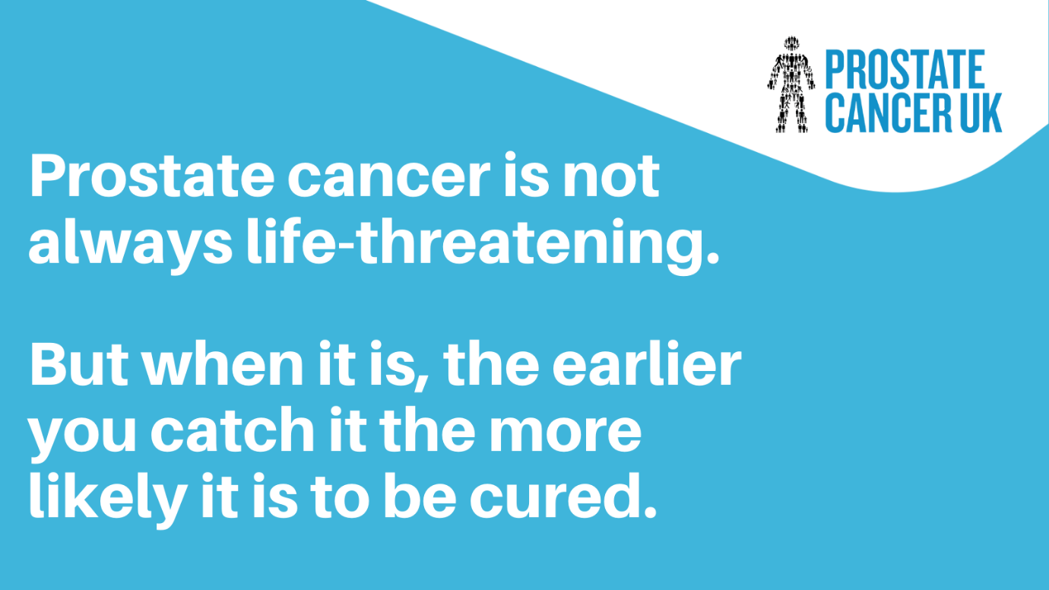
Most men with early prostate cancer don’t have any signs or symptoms. But there are some things that may mean you're more likely to get prostate cancer. Check your risk online here: https://prostatecanceruk.org/risk-checker
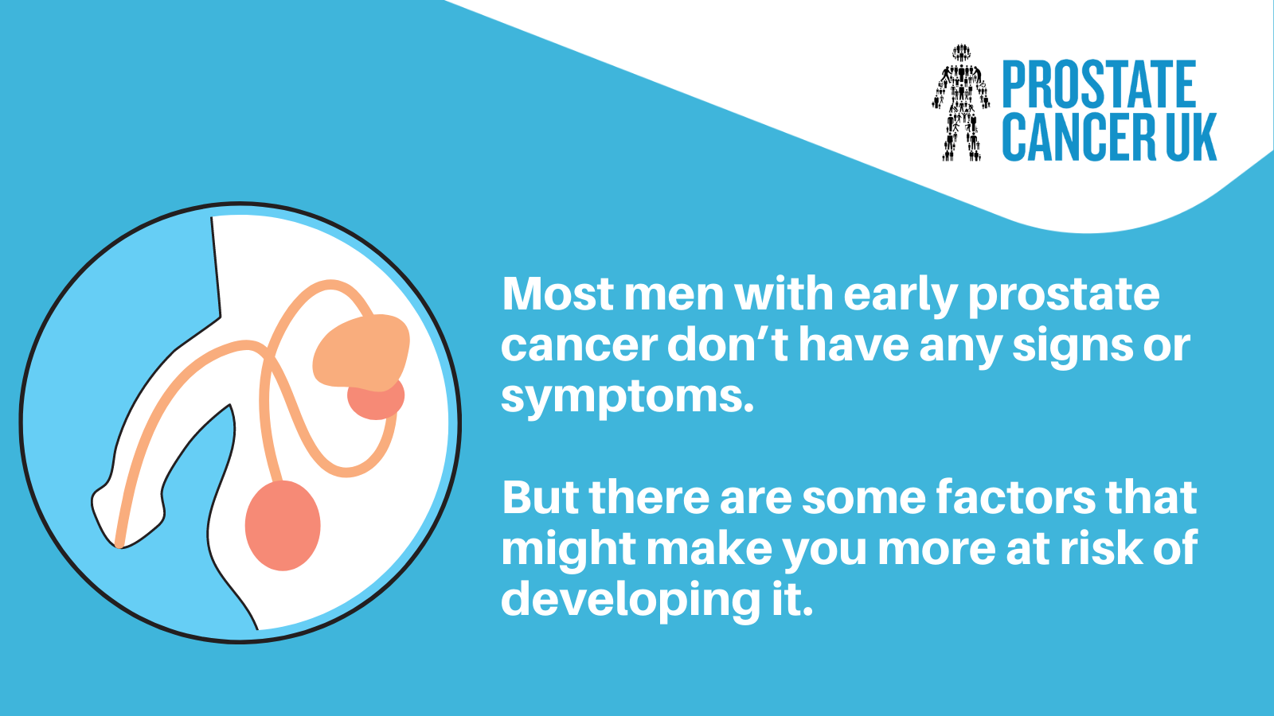
Oral Health Day 20th
It's World #OralHealth Day today and you can find lots of advice on how to keep your smile in top condition, whatever your age, online here: www.derbyshire.gov.uk/oralhealth

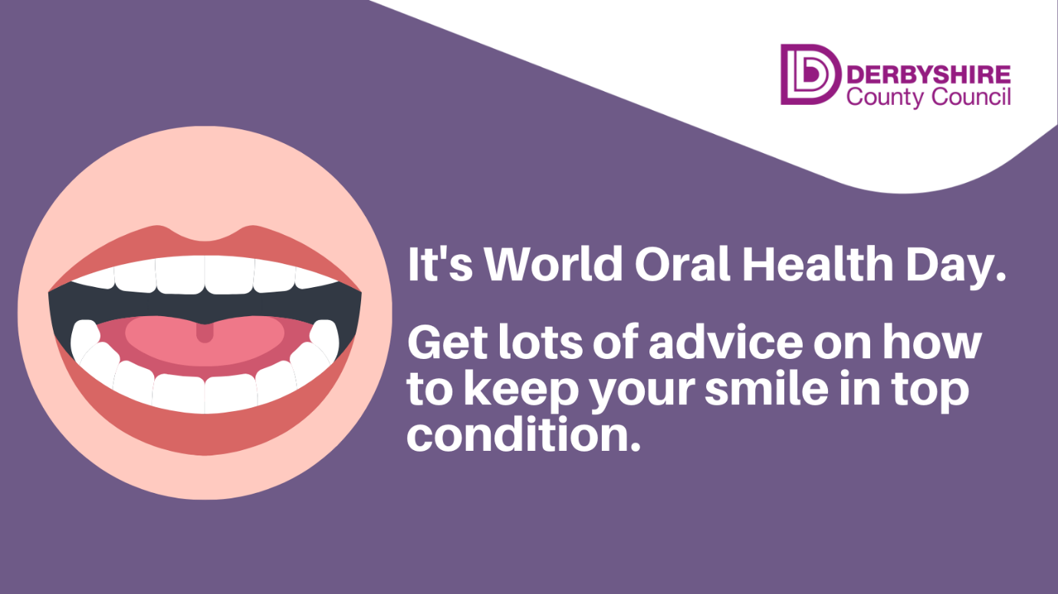
It's World #OralHealth Day & the perfect time to perfect that smile! No matter how old you are, it's never too late to take good care of your teeth. Get advice online here: www.derbyshire.gov.uk/oralhealth

It's World #OralHealth Day. If you want advice on how to keep your family’s teeth and gums healthy then check out the children’s oral health animations on Derbyshire County Council’s YouTube channel here.
Other National Campaigns you may want to share

Ash – No Smoking Day 8th March
Find out more about the national No Smoking Day campaign on Ash’s website. You can download resources, fact files and more. https://ash.org.uk/

Payslip / intranet / newsletter copy
No Smoking Day
March 8th is No Smoking Day – a great time to quit for good!
Stopping smoking is one of the best things you can do for your health and if you're ready to quit for good then there's lots of support on offer.
NHS Smokefree has lots of top tips and advice on how to kick the habit for good. Find out more at https://www.nhs.uk/smokefree
You can get FREE stop smoking support through Live Life Better Derbyshire. It's a healthy lifestyles services that offers help to Derbyshire residents on a wide range of issues including stopping smoking, losing weight and getting more active.
Find out more at www.livelifebetterderbyshire.org.uk or call 0800 085 2299.
You can also download the FREE My Quit Route app. Full of useful support to help you stop for good.
Download it from the ORCHA website here: https://derbyshire.orcha.co.uk/defaultsearch/?search=my%20quit%20route

