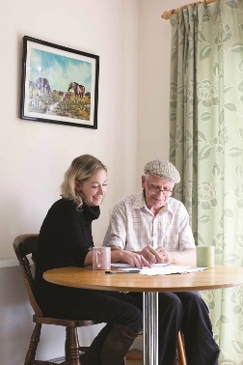

**Communication & Customer Service**

**Planning & Organisation**

**Recording and Monitoring**

**Leadership**

**Quality**

**Team Work**

**Charity Focus**

**Specialist Knowledge**



**Support Worker (MHSOP Support Service)**

**Hours: 37 hours per week**

**Salary: £20,520 per annum, AUNN Band D**

**Based: Predominantly home based with occasional community visits (City & County)**

**Tenure: Fixed term until 31st March 2024 (any extension being subject to funding)**

The Mental Health Service for Older People (MHSOP) Support Service provides short term support to older people on discharge from MHSOP wards going back into the community, or into a care setting; in addition to those living in the community who are under the care of community mental health services. Referrals are received through designated pathways and the service is also available to their families/carers.

The successful candidate will provide telephone and face to face support where needed to provide welfare checks (ensuring urgent access to food, heating etc), an independent listening ear to discuss any worries or concerns; as well as identifying with the individual other services e.g. community groups, practical services (shopping, gardening), benefit checks, and statutory services where appropriate, to help them maintain their independence and live well.

With an awareness of the issues faced by vulnerable people, and those of their families/carers, we are looking for an individual who is empathetic, sensitive, and able to work in a holistic way with those they are supporting. Self-motivation and discipline are key to this role, which will involve a significant element of working from home and therefore the successful candidate must be able to work independently, as well as part of the wider team, and be able to travel across Nottingham city and county as needed. Managing a busy caseload, excellent organisational, interpersonal and IT skills are also key.

*As an employee of Age UK Nottingham & Nottinghamshire you will be eligible for our attractive package which includes 24 days annual leave (Pro Rata), public holidays, flexible working and a 4% employer contribution pension (in line with auto-enrolment rules).*

**How to Apply**

For full details and to download an application pack, please visit our website at www.ageuk.org.uk/notts. Alternatively, please contact our HR department for an application pack by **email recruitment@ageuknotts.org.uk** or **telephone 0115 859 9265.**

**The closing date for receipt of completed applications is Monday 27th March at 9am**

Age UK Notts promotes equality and diversity. Registered Charity Number: 1067881