# 

Food Hubs

Information and Guidance

Cost of Living Support

The cost of living is affecting all of us, and the Food Hubs are just one way we felt we could help parents and local people.

There is lots of other support available in Bassetlaw, all of which has been put together in a “Cost of Living Booklet” by Bassetlaw Community and Voluntary Service.

The booklet and all the support available is available to view online here:

[www.bcvs.org.uk/costofliving](http://www.bcvs.org.uk/costofliving)

If you would like a paper copy of the book please email bcvs@bcvs.org.uk who would be happy to either post you one or let you know where to collect one.

________________________________________

###### For all food hubs, as well as other information about the Bassetlaw Food Insecurity Network, please visit: [www.bcvs.org.uk/bfin](http://www.bcvs.org.uk/bfin)

________________________________________

###### If you would like more information about Bassetlaw Community and Voluntary Service, including details about volunteering in your local community, please visit:

###### [www.bcvs.org.uk](http://www.bcvs.org.uk)

Useful QR codes (scan them with your camera phone to go directly to the websites and organisations mentioned in this booklet)

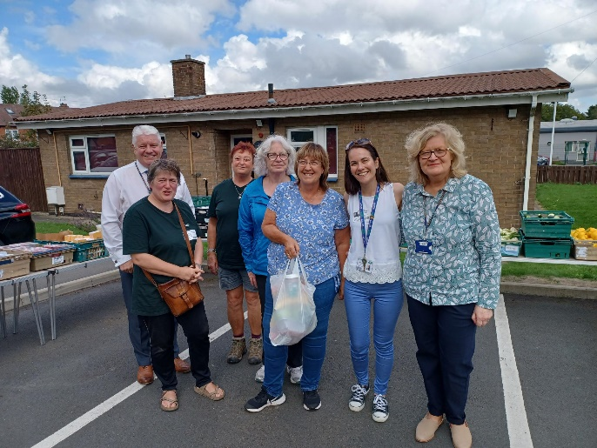

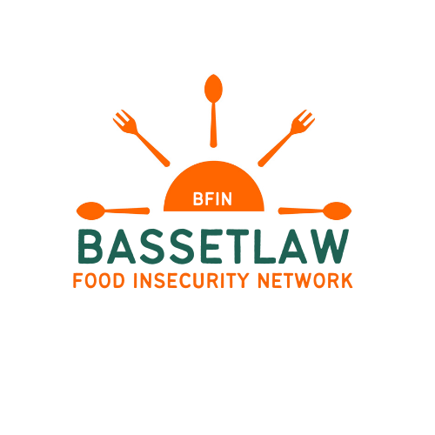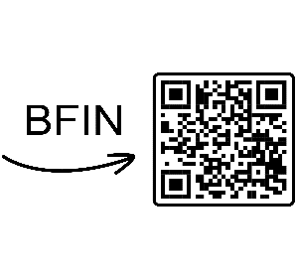

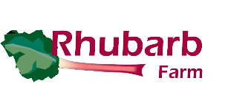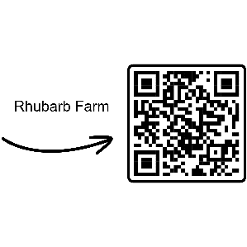

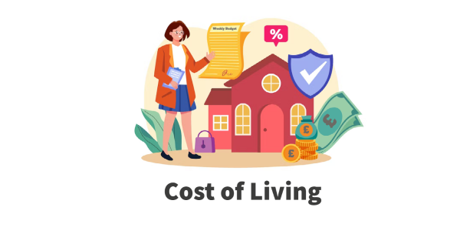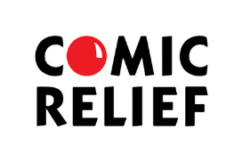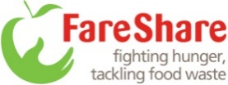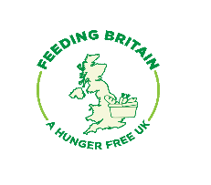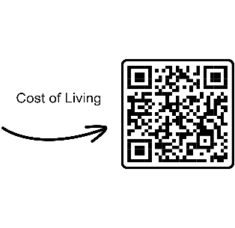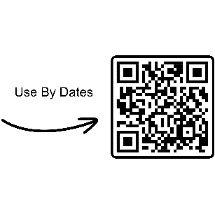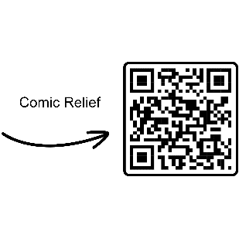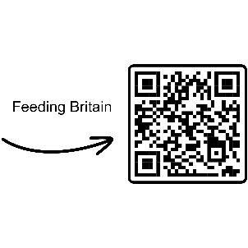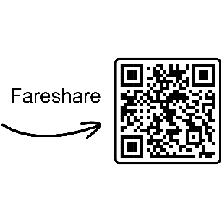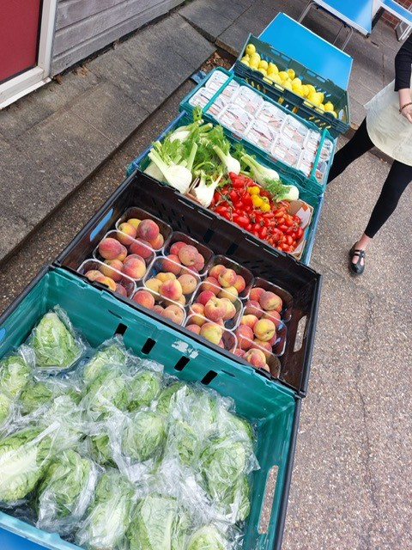

# Rhubarb Farm Tour | Derbyshire Voluntary ActionChanges to Feeding Britain's governance - Feeding BritainFareShare | Fighting hunger, tackling food waste in the UKNottinghamshire County Council | Tile Hill

###### DISCLAIMER

###### Ordsall Primary School and it’s representatives shall inspect and confirm that all donated food products received from Fareshare and any other partner organisations are in good order.

###### 

###### Ordsall Primary School and all affiliates and partners in relation to the Food Hubs, including employees, parent helpers and volunteers, make no representations, warranties or guarantees with regards to the quality or hygiene of the donated food products.

###### Once the donated food products are received by the purchaser, Ordsall Primary School and all affiliates and partners, shall not be responsible for any adverse reactions, side effects, injury, bodily harm or death that results from consumption of the donated food products or any other liability arising thereof.

###### All food is sold as seen and no refunds are available.

###### For information regarding Use By dates and Best Before dates please visit the Food Standards Agency advice page:

###### [www.food.gov.uk/safety-hygiene/best-before-and-use-by-dates](http://www.food.gov.uk/safety-hygiene/best-before-and-use-by-dates)

###### The Food Hubs are coordinated by Bassetlaw Food Insecurity Network (BFIN. The BFIN coordinator is employed by BCVS through funding from Notts County Council. Funding to support the Food Hubs has been provided by Comic Relief in conjunction with Feeding Britain.

###### The Food Hubs are initially supported by BFIN, with the operations managed by Rhubarb Farm for the first 8 weeks. During this time, training is given to the school.

###### Once the training is completed, the operations are then passed over to the School team.

###### There are a variety of other Food Hubs available in Bassetlaw, most of which are open to the whole community.

###### 

###### https://fareshare.org.uk/wp-content/uploads/2019/07/fs-logo.jpg

###### The food you buy at the Food Hubs is provided by a variety of organisations that have partnered up with us to ensure that any surplus food that they have is not thrown away.

###### The majority of the food you buy at the food hubs comes from FareShare.

###### FareShare is designed to take large volumes of surplus food from the food industry. They then divert it to their UK-wide network of 9,500 charities, schools, groups and community members.

###### This means the food can be sold to people that can make use of it so as well as saving it from going to landfill, it saves you money too.

###### Each week, there will always be a selection of vegetables/fruit as well as protein items and then the other items available will depend on the stock received from FareShare and other partners.

###### Some weeks will be better than others, but every week will always be fantastic value for £3 a bag.