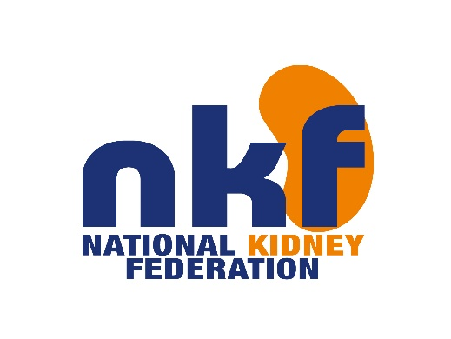

**Job Title:** Social Media and Office Administrator

**Location:** NKF Headquarters, Worksop, S81 8BW

**Reporting to:** Office Manager & Head of Marketing

**Hours:** 36 hours

**Salary:** Up to £19,400

___________________________________________________________________________

As Social Media and Office Administrator, you will be responsible for the growth in engagement, updating and daily management of the NKF’s social media channels. You will also be the primary point of contact for patients, members, supporters, and stakeholders. You will provide administrative support to the team and be responsible for updating our database, as well as supporting the running of our patient engagement projects, events, and our office.

**Main duties and responsibilities:**

* Progress the NKF social media strategy and develop plans that drive engagement and revenue
* Act as the main administrator on all social networking accounts for NKF
* Keep up-to-date with social media trends and competitor activity, providing monthly reports and recommendations to the Head of Marketing
* Work with the Communication and Marketing team to develop a quality digital offering across all channels belonging to NKF
* Develop engaging, creative and innovative content for social media plans that promote the NKF and drive engagement & revenue
* Design promotional materials for the charity
* Become an advocate for NKF in social media spaces, engaging in dialogues and answering questions where appropriate
* Provide a high level of administrative support to all areas of the charity
* To be the first point of call for all visitors to the building and to manage the main reception, email address and main telephone line
* Update Blackbaud (database) and filing systems
* Provide administration support for fundraising and charity events
* Liaise with the accounts department to ensure timely process of income
* Organise mailings to members, supporters, and donors
* Support with office supply management

**General Responsibilities:**

* Co-operate with all staff in maintaining good relationships with outside agencies and the general public in order to uphold the charity's image and win increased support for its work
* Maintain confidentiality in all areas of work
* Ensure that your conduct does not conflict with professional expectations.
* Actively support and promote the NKF strategy and values
* Co-operate with all staff in maintaining harmonious inter-personal relationships
* Ensure an awareness and observation of Fire and Health and Safety Regulations
* Carry out any other duties as are within the scope, spirit and purpose of the job, the title of the post and its grading as requested by your Line Manager or the Chief Executive

Note: This job description reflects the present requirements of the post. As duties and responsibilities change and develop, the job description will be reviewed and is subject to amendment in consultation with the post holder.

**Person specification:**

* Experience of working in the charity sector would be beneficial
* Minimum of 2 years’ experience in a social media marketing capacity
* Extensive knowledge of all social media platforms and how each platform can be deployed in different scenarios
* Proven administration experience
* Experience of database use - Skills / Knowledge/ Abilities
* Experience of using photoshop and Canva
* Exceptional organisational skills
* Good IT skills including the ability to use Microsoft Outlook, Excel and databases and to learn unfamiliar packages quickly and effectively
* Ability to work within the bounds of confidentiality
* Ability to think and work independently when needed
* Excellent attention to detail
* Ability to act on own initiative and organise personal workloads effectively Communication & Interpersonal Skills
* Excellent communicator with good interpersonal and listening skills.
* Strong written and verbal communication skills

NKF is committed to promoting equality and diversity.