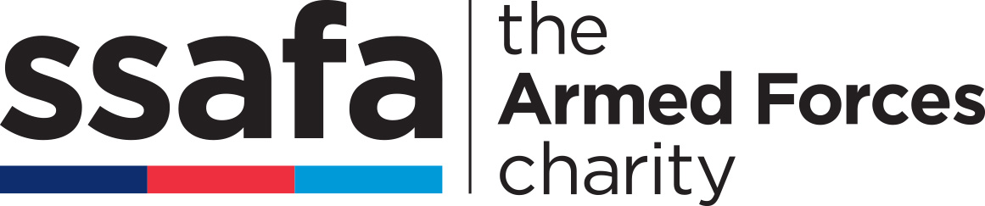
REGIONAL FUNDRAISING OFFICER

£28,000 per annum plus company car

Full time, 37.5 hours per week

Permanent contract

Homebased in the East Midlands

SSAFA’s regional fundraising team, operating across the UK, supporting 90 Branches, are proud to announce that due to an internal promotion this role as part of their strategic growth and ambitious development plans has become available.

About the role

This is a brand-new fundraising opportunity that covers the wide range of counties throughout the East Midlands. Supported by the Regional Fundraising Manager, this role is fundamental in developing, supporting and championing new and existing fundraising initiatives to increase income generation in this area whilst raising SSAFA’s profile. This initiative includes (but is not limited to) trusts and foundations, companies, membership organisations, sports, education and government bodies, high-net worth donors, community-based partnerships, and grassroots fundraising through events and activities.

SSAFA is entering into an exciting period of strategic development within regional fundraising. This may open a range of opportunities for career development within the team and the organisation. If successful, you will join a team of Regional Fundraising Officers already recruited throughout the UK.

There will be an occasional need to travel across the UK and to work evenings and weekends at key events.

About the team

You will join a small, well-established and dedicated team who cover the whole of the UK, working with 90 Branches and Service committees. With regular team meetings and a variety of communication mediums you will be given ongoing support, training and mentoring throughout. We are a remote team and well connected to all colleagues. This supports and drives our determination and success.

About you

We are looking for an exceptional candidate, who thrives on challenge. A determined, highly motivated individual, with a track record of securing significant funds through a variety of income streams. A natural communicator with proven success in working with and developing volunteers to support this growth. A confident networker, able to represent the charity to external stakeholders, build relationships and reputation, communicate effectively across the region whilst working from home.

About SSAFA

SSAFA, the Armed Forces charity, has been providing practical, emotional, and financial support to our Forces and their families since 1885. Last year our teams of volunteers and employees helped more than 79,000 people in need, from Second World War veterans to those who have served in more recent conflicts or are still currently serving, and their families.

SSAFA understands that behind every uniform is a person. We are here for that person – any time they need us, in any way they need us, for as long as they need us.

Diversity and Inclusion at SSAFA

SSAFA exists to support a diverse range of beneficiaries within the armed forces community, and we believe diversity within our teams is key to ensuring we can deliver our services effectively. We thrive on differences and believe it is critical to our success as a worldwide charity. SSAFA is proud to be an equal opportunity workplace that seeks to recruit, develop and retain the most talented people from a variety of backgrounds, perspectives, and skills. We therefore encourage applications from all genders, races, religions, ages and sexual orientations, as well as parents, veterans, people living with disabilities, and any other groups that could bring diverse perspectives to our business.

SSAFA is committed to using the Disclosure & Barring Service to ensure we, as an employer, safeguard those we serve.

Further information about the role

If you have any queries or would like to speak to someone about this role, please contact Paul Smithurst on 07385 943466 for an informal discussion.

No agencies please. Any unsolicited submissions from agencies will be accepted as a direct application from the candidate and no fees will be payable.

How to apply

You can apply via SSAFA’s website where you’ll also find information about our application process.

Closing date: Midnight on Sunday 3rd July 2022

Interviews: Virtual interview, date TBC.

If you wish to apply for any of our vacancies you will be asked to provide personal information, answer screening questions and upload a copy of your CV. You will remain anonymous to the hiring panel until the shortlisting has been completed. Personal data to progress your application for employment is covered under the General Data Protection Regulations (GDPR) Article 6 Section 1b and Article 9 2b and c. Your details will not be used for any other purpose or shared with a third party without your permission. Data on unsuccessful candidates will be retained for one year from the vacancy being filled. If you take up employment with us, your information will be held for the duration of your employment plus six full calendar years. Further details are contained in SSAFA’s Privacy Statement at https://www.ssafa.org.uk/policy-hub/job-applicant-privacy-policy

