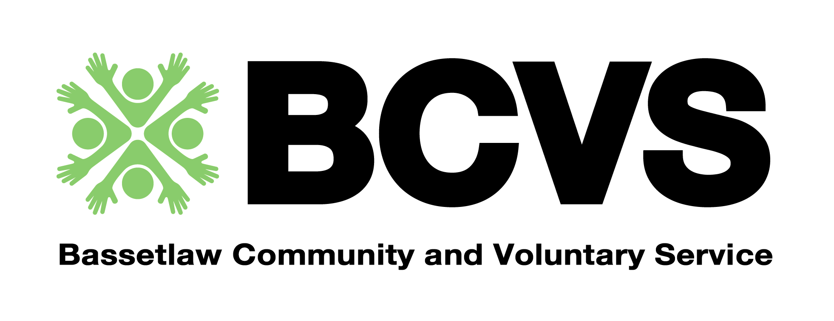

Bolsover VCS Community Connection Coordinator

(Group development and tackling loneliness)

Hours: 18.75 hours per week
Salary: £23,136 to £26,003 FTE subject to experience
Contract Term: Initially a 12- month fixed term contract with planned extension subject to funding
Reporting to: Bolsover Team Lead
This post is available as part of a full time role if combined with another BCVS vacancy currently being advertised.
Please get in touch to discuss if you are interested in more than one half time role. You are welcome to submit one application form to cover more than one role, however please ensure that you address the all items on all person specifications you are applying for within the application.
General Role Description

The Bolsover VCS Bolsover VCS Community Connection Coordinator is a key ‘on the ground’ voluntary sector post. The post will work remotely throughout the District of Bolsover from community based locations, to support the growth and development of the VCS activity and social action with a particular focus on Social Connectedness/tackling loneliness, codesign, and supporting articulation and amplification of voice within place based and district partnership fora and meetings.

As such, the role requires someone with strong inter-personal skills, sound knowledge of the Bolsover VCS and wider stakeholders including statutory partners, and someone who is both well organised and capable of operating at both strategic and operational levels.

We welcome applicants from all backgrounds and communities, and in particular those that are currently under represented in our workforce.

Job Description

- Lead and support the development of VCS networks throughout the district of Bolsover.

- Support and, where appropriate, lead project work within local and county partnerships.

- Effective regular liaison/communication with statutory partners, providing a two-way link with the voluntary and community sector.

- Support and development of local voluntary organisations and community groups. Identify synergies of provision and develop collaborative relationships with a particular focus on Social Connectedness and tackling loneliness.

- Explore and promote funding opportunities for relevant voluntary organisations and community groups from national, regional and local sources.

- Support relevant partners to identify gaps in service and, where appropriate, setup new groups and help existing groups establish services that meet an identified need.

- Support statutory partners to develop effective and sustainable relationships with communities and the voluntary and community sector including facilitation of codesign activities.

- Provide a voice for the groups by co-ordinating a collective response to influence change and shape services - have an ability to represent the sector and support them to represent themselves.

- Attendance at relevant BCVS internal and external events/meetings.

- Attendance at relevant external conferences and training events.

- Actively gather local insight regarding VCS activity and support the growth of the VCS contact database.

- Generate relevant content for the Bolsover e-bulletin – information will include upcoming events, relevant sector information and funding and commissioning opportunities.

- Maintain the confidentiality of sensitive personal and organisational information, in line with the organisations confidentiality policy and GDPR regulations.

- Flexibility is required within the remit of this post and additional duties may be required from time to time.

Person Specification - Required Skills, Competencies and Experience include:

- Knowledge & experience of the voluntary / community sector
- Experience of working with statutory agencies and particularly the health sector in Derbyshire
- ICT and PC skills, particularly MS Office programs
- Excellent networking and interpersonal skills
- Good communication skills (verbal and written)
- Ability to work on own initiative
- Ability to work in a small flexible team and establish positive relationships with team members
- Strong organisational skills
- A strong understanding of group set up, governance, structure and ongoing support.
- Experience of writing funding bids and supporting organisations to develop applications
- Ability to work to tight deadlines
- A willingness to work flexibly within the total number of hours per week as determined by operational priorities
- Proactive commitment to Sustainability, Inclusion, Diversity and Equality
- A current Driving Licence and own transport

Flexibility is required within the remit of this post and additional duties may be required from time to time.

