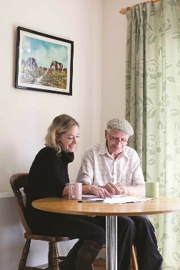
Communication & Customer Service
Planning & Organisation
Recording and Monitoring
Leadership
Quality
Team Work
Charity Focus
Specialist Knowledge

Senior Support Worker

Hours: 37 hours per week (part-time may be considered)
Salary: £22,080 per annum, AUNN Band E
Based: Field based across Nottingham City & County* with some home working
Tenure: Fixed term 12 months from appointment

Do you what have it takes to support the carers of people with moderate to severe dementia/mental illness out in the community? Are you able to work in a holistic, person-centred and enabling way with the carer, promoting choice, self-determination and fostering connection to local communities; ensuring that they have a positive experience of care and support? Do you have excellent leadership skills to line manage a small team of support workers? If so, this is an exciting new project running for 12 months in the first instance.

The successful candidates will:
- be self-starters, able to work independently as well as part of a team
- possess excellent organisational, interpersonal and IT skills
- be able to work closely and collaboratively with colleagues in mental health & other partners
- have an excellent understanding of the needs and concerns of carers supporting people with dementia/mental illness

* The Senior Support Worker will be assigned their own geographical area; either Bassetlaw and Mid Notts (Mansfield, Ashfield, Newark & Sherwood) or Nottingham City & South Notts (Broxtowe, Gedling and Rushcliffe); however they will be required to support their team and attend meetings county wide as needed. Please specify on your application form which areas you would like to be considered for as your main area.

As an employee of Age UK Nottingham & Nottinghamshire you will be eligible for our attractive package which includes 24 days annual leave (Pro Rata), public holidays, flexible working and a 4% employer contribution pension (in line with auto-enrolment rules).

How to Apply
For full details and to download an application pack, please visit our website at www.ageuk.org.uk/notts. Alternatively, please contact our Human Resources department for an application pack by email recruitment@ageuknotts.org.uk or telephone 0115 8599265.

The closing date for receipt of completed applications is Monday 30th May at 9am.

Age UK Nottingham & Nottinghamshire promotes equality and diversity.
Registered Charity Number: 1067881

