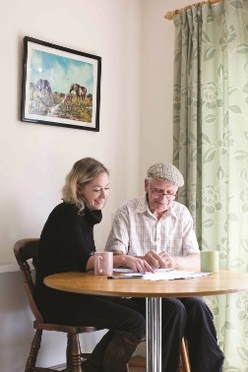
Communication & Customer Service
Planning & Organisation
Recording and Monitoring
Leadership
Quality
Team Work
Charity Focus
Specialist Knowledge

Footcare Service Assistant

Hours: 18 hours per week over 3 days (Monday, Tuesday, Friday)
Salary: £9,739 per annum, pro rata AUNN Band C (£20,020 FTE)
Based: Field based – Nottingham City
Fixed term until 31st March 2025

We have an exciting opportunity for an individual to join our Footcare Team, providing a simple social nail cutting and basic foot care advice service for older people aged 50+, who are not able to cut their own toenails due to age or disability, at health venues across Nottingham City.
Having a good awareness of the issues affecting the health and wellbeing of older people in the community, the successful candidate will have strong interpersonal and verbal communication skills, be able to lone work whilst being part of team and have excellent organisational and IT skills. The role will also require you to undertake service promotion, be able to signpost older people to other services as needed, and cover for the service administrator as needed.
Due to the nature of the role the postholder will be required to have access to a car and be able to transport bulky equipment between venues*. Experience of providing footcare services would be beneficial but is not essential as training will be given.

As an employee of Age UK Nottingham & Nottinghamshire you will be eligible for our attractive package which includes 24 days annual leave (Pro Rata), public holidays, flexible working and a 4% employer contribution pension (in line with auto-enrolment rules).

*Age UK Notts is committed to making reasonable adjustments, so whilst this job requires the jobholder to drive, your application will still be considered if you are unable to drive due to a disability

How to Apply
For full details and to download an application pack, please visit our website at: www.ageuk.org.uk/notts.

Alternatively, please contact our Human Resources department for an application pack by email recruitment@ageuknotts.org.uk or telephone 0115 859 9265.

The closing date for receipt of completed applications is
Wednesday, 18th May 2022 at midday

Age UK Nottingham & Nottinghamshire promotes equality and diversity.
Registered Charity Number: 1067881

