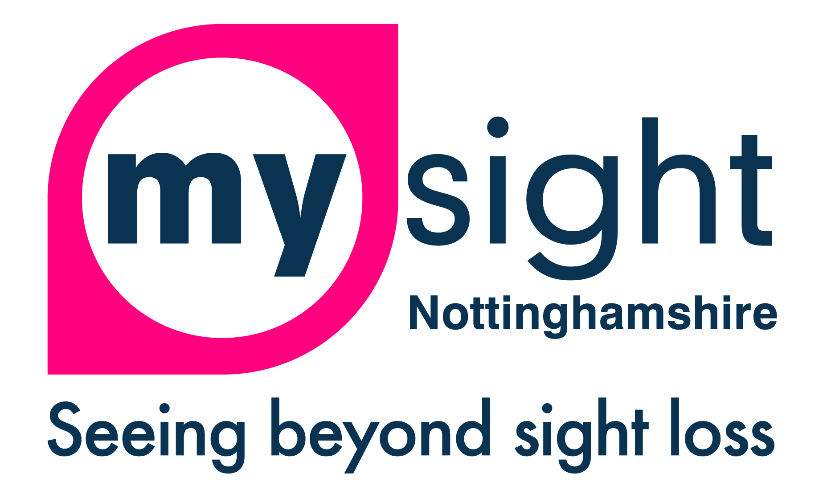

Equal Opportunities Monitoring Form
We are an Equal Opportunities organisation. We aim to provide equality of opportunity to all persons regardless of their religious belief; political opinion; sex; race; age; sexual orientation; or, whether they are married or are in a civil partnership; or, whether they are disabled; or whether they have undergone, are undergoing or intend to undergo gender reassignment.
We do not discriminate against our applicants on any of the grounds listed above.
You are not obliged to answer the questions on this form

Sex: Male Female Transgender

Age: 16-25 26-40 41-50 51-60 61+

Sexual Orientation: Straight Gay/Lesbian Bi-sexual

Marital Status: Single Married Widowed Divorced

Ethnicity: White British Black British
White European Black Caribbean
White Irish Black African
White Other Black Other
Pakistani Chinese
Indian Japanese
Bangledeshi Other (please state)
Mixed Race ________________
Religion: Christian Muslim Hindu None
Jewish Buddhist Sikh
Other (Please state) ______________________

Do you consider yourself to have a disability: Yes No
If yes, please indicate the nature of your disability
Physical Impairment
Sensory Impairment
Mental Health Condition
Learning Disability
Other (please state) _____________________________

Do you have any caring responsibilities? Yes No
If Yes, do you care for..
Child/Children Disabled Person(s) Elderly Person(s) Other

Thank you for taking the time to complete this questionnaire

