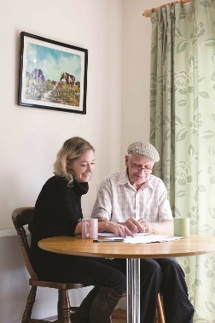

**Communication & Customer Service**

**Planning & Organisation**

**Recording and Monitoring**

**Leadership**

**Quality**

**Team Work**

**Charity Focus**

**Specialist Knowledge**



**Carer Support Worker – Mental Health Services for Older People (MHSOP)**

**Hours: 37 hours per week (part-time may be considered)**

**Salary: £20,117 per annum, AUNN Band D**

**Based: Field based across Nottingham City & County* with an element of home working**

**Tenure: Fixed term - 6 months from appointment**

**Number of Posts: 8\***

As a Carer Support Worker – MHSOP, you will be supporting carers of people with moderate to severe dementia/mental illness out in the community (where the cared for person is being supported by MHSOP Community Teams), in order that they remain mentally and physically well. The Carer Support Worker will work in a holistic, person-centred and enabling way with the carer, promoting choice, self-determination and fostering connection to local communities; ensuring that they have a positive experience of care and support, through your support and practical assistance in relation to their current and future needs.

The successful candidate will be a self-starter, with excellent organisational, interpersonal and IT skills; be able to work independently as well as part of a team, working closely and collaboratively with our colleagues in mental health and other statutory services; as well have an excellent understanding of the needs and concerns of carers of those supporting people with dementia/mental illness as well as the cared for. Personal experience of being a carer or providing peer support would be advantageous, but is not essential.

* The Carer Support Worker will be assigned their own geographical area; however they may be required to support other areas as needed. The geographical areas and number of assigned workers are: Bassetlaw, Mansfield & Ashfield, Rushcliffe, Newark & Sherwood, Broxtowe, and Gedling x 1, and Nottingham City x 2 workers. Please specify on your application form which areas you would like to be considered for as your main area.

*As an employee of Age UK Nottingham & Nottinghamshire you will be eligible for our attractive package which includes 24 days annual leave (Pro Rata), public holidays, flexible working and a 4% employer contribution pension (in line with auto-enrolment rules).*

**How to Apply**

For full details and to download an application pack, please visit our website at: [**www.ageuk.org.uk/notts**](http://www.ageuk.org.uk/notts). Alternatively, please contact our Human Resources department for an application pack by email [**recruitment@ageuknotts.org.uk**](mailto:recruitment@ageuknotts.org.uk) or telephone **0115 859 9265**.

**The closing date for receipt of completed applications is Friday 7th January 2022 at 12pm.**

Age UK Nottingham & Nottinghamshire promotes equality and diversity.

*Registered Charity Number: 1067881*