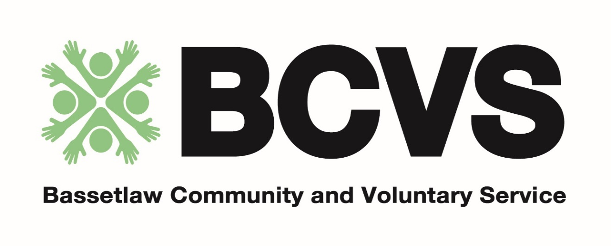

Role Description
Bassetlaw Community and Voluntary Service
Executive Committee and Trustees

- The general approach to the work of the Bassetlaw Community and Voluntary Service [BCVS] is summarised in the BCVS Trustees Annual Report.

- Members of the BCVS Executive Committee act as trustees for the BCVS being corporately responsible for such areas as:
The total BCVS budget
Employment of Staff
BCVS Building and capital

- A working knowledge of the BCVS and the District is an advantage.

- The BCVS is bound by several Key Policies including:
- Equal Opportunities
- Anti Racism
- Health and Safety
- Safeguarding
- Sustainability

The BCVS is non partisan in all its work.

The BCVS Executive Committee and Trustees meet five times per year.

Name of affiliate member to the BCVS:

We wish to nominate the following as a member of the BCVS Executive Committee as a Trustee.

Name:

Address:

Full telephone number:

I am willing to stand as a member of the BCVS Executive Committee and as a Trustee.
I have read the ‘Role Description’ for Members.
I have read the information on the responsibilities of Trustees.

Signed:

Please return to the BCVS by 15th November 2021 with a completed application form.

Nominations received after this time will not be accepted in this recruitment cycle however please get in touch to discuss further.

